# Computer science NEA - Flow Field

## Dan Salter

**Analysis** **4**

Introduction 4

What is a flow field? 4

What is Perlin Noise? 4

Software 7

Objectives 9

**Documented design** **10**

Setup 11

Flow field generation 13

Particle class 17

Fields 17

Methods 17

Spawn particles 18

Particle handling 18

HCI 19

**Technical solution** **20**

Construct a grid of unit vectors. Each vector’s direction will be related to its neighbours’ by passing the coordinates of its grid square into the 2-dimensional Perlin Noise function. Each vector represents a force that will be applied to any particle located in its respective grid square. 20

Have a “Particle” object that is able to react to forces applied to itself using vector fields for position, velocity and acceleration. 22

Write a function that calculates which square of the grid each particle is located in before applying a force to the particle at the angle of the vector for that grid square. 24

Add a mouse listener function that, when a mouse button is held, spawns particles onto the canvas in the region of the cursor. 25

Remove particles from the simulation that pass outside the edges of the canvas to improve the efficiency of the programme. 26

Give all particles a “lifespan” field so when that set time elapses the particle is erased from the simulation. 27

Add a menu in the corner of the canvas that allows you to select the colour any new particles will be drawn as. 28

Change the way particles are drawn so the RGB value of the pixel where a particle is located is incremented by only a small amount, as opposed to changing the pixel to a block colour, to give the visual effect of the screen slowly becoming brighter in areas where more particles pass. 30

Randomising particle attributes: 31

lifespan 31

limit 31

Initial velocity 31

Band A technical skills: 32

Hash tables, lists, stacks, queues, graphs, trees or structures of equivalent standard 32

List operations 32

Complex user-defined use of object oriented programming (OOP) model, eg classes, inheritance, composition, polymorphism, interfaces 32

Dynamic generation of objects based on complex user-defined use of OOP model 33

Complex scientific/mathematical/robotics/ control/business model 33

**Testing** **33**

Does the flow field generation algorithm work when the random() function is used to generate the vectors? 34

Does the flow field generation algorithm work when the noise() function is used to generate the vectors? 35

Do particles added to the simulation follow the direction of the flow field? 36

Are particles removed from the simulation upon exiting the window? 36

Are particles removed from the simulation when they have exceeded their set lifespan? 36

Are particles given a random velocity when they are spawned? 36

Are new particles drawn with the intended colour after after a new colour is selected using the palette? 37

Testing the effect of changing the placement of the background(): 38

When background() is in the draw() function 38

When background() is in the setup() function 38

Testing the effect of changing the values of the constants initialised at the beginning of the program: 38

Scale 38

When SCALE = 100, INCREMENT = 0.1 (zoom x1000) 38

When SCALE = 20, INCREMENT = 0.02 (zoom x1000) 39

When SCALE = 1, INCREMENT = 0.001 (zoom x1000) 40

INCREMENT 40

When SCALE = 5, INCREMENT = 0.005 (zoom x1000) 41

When SCALE = 5, INCREMENT = 0.025 (zoom x200) 42

When SCALE = 5, INCREMENT = 0.001 (zoom x5000) 43

SPEED 44

When SPEED = 1 44

When SPEED = 3 44

When SPEED = 5 44

TRAIL_LENGTH 44

When TRAIL_LENGTH = 30 44

When TRAIL_LENGTH = 80 44

When TRAIL_LENGTH = 150 44

BRIGHTNESS 45

When BRIGHTNESS = 1 45

When BRIGHTNESS = 5 45

When BRIGHTNESS = 255 45

DENSITY 45

When DENSITY = 1 45

When DENSITY = 20 45

When DENSITY = 100 45

**Evaluation** **48**

Construct a grid of unit vectors. Each vector’s direction will be related to its neighbours’ by passing the coordinates of its grid square into the 2-dimensional Perlin Noise function. Each vector represents a force that will be applied to any particle located in its respective grid square. 48

Have a “Particle” object that is able to react to forces applied to itself by adjusting its vector fields for position, velocity and acceleration. 48

Write a function that calculates which grid square each particle is located in so that the relevant force can be applied to the particle at the correct angle. 49

Add a mouse listener function that, when a mouse button is held, spawns particles onto the canvas in the region of the cursor. 49

Remove particles from the simulation that pass outside the edges of the canvas to improve the efficiency of the programme. 49

Give all particles a “lifespan” so when that set time elapses the particle is erased from the simulation. 50

Add a menu in the corner of the canvas that allows you to select the colour any new particles will be drawn as. 50

Change the way particles are drawn so the RGB value of the pixel where a particle is located is incremented by only a small amount, as opposed to changing the pixel to a block colour, to give the visual effect of the screen slowly becoming brighter in areas where more particles pass. 50

Independent review: 51

Improvements: 51

**Appendix** **51**

Code 51

# Analysis

## Introduction

My project will be built on the concept of flow fields. I want to investigate the different styles of aesthetically pleasing graphics that can be generated using them. I first came across flow fields on the chrome experiments website1 and was immediately intrigued about what code was behind something so visually satisfying. At the time I had not yet come across the term “flow field” and there was no documentation explaining the concept for this specific project; some time passed before I came across any kind of explanation. I eventually came across a video on Dan Shiffman's YouTube channel explaining how he created something that was visually akin to the project I had seen on chrome experiments using the Perlin Noise function in the “p5.js” JavaScript library he developed. This inspired me to first create my own flow field program in processing then from that point investigate what different visually interesting things I can create using that as a base.

## What is a flow field?

A flow field is a simulation that uses a basic physics engine to push a particles around the screen, following the directions of an invisible grid of vectors. In my program the grid of arrows will be represented as an array of unit vectors whose directions are set equal to the return value of the 2-dimensional Perlin Noise function with different parameters.

For each frame a force is applied to each particle in the direction of the arrow belonging to the grid square the particle is located in at that point in time. When you hide the grid of arrows this flowing particles look similar to sand swirling in water or birds flocking together.

## What is Perlin Noise?

Perlin Noise is a function that “produces a naturally ordered (“smooth”) sequence of pseudo-random numbers.” The function works by procedurally generating an infinitely large 3-dimensional array of floating point numbers between 0 and 1. This “array” can envisaged as a 3-dimensional graphical space where each specific point in space is allocated a value between 0 and 1. This space can be accessed in 1-dimension, 2-dimensions and 3-dimensions by passing either one, two or three parameters to the function respectively.

The property that makes Perlin Noise unique is that the values it generates are related to their neighbours. This property makes it ideal for projects such as creating smoothly textures for flowing water or generating a hilly terrain in a video game.

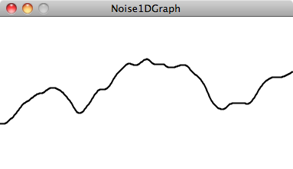

**Fig.1 - Graph generated using 1D Perlin Noise**

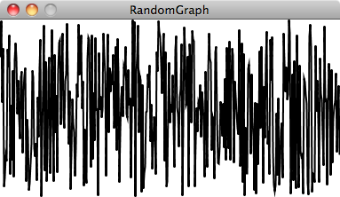

**Fig.2 - Graph generated using random() function**

Figure 1 depicts a graph of the 1-dimensional Perlin Noise function, drawn by plotting the parameter on the x-axis and returned value on the y-axis. Figure 2 shows a similar graph of a series of numbers between 0 and 1 generated using the random() function.

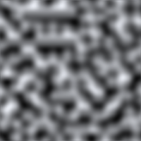

**Fig.3 - A texture generated using 2D perlin noise**

The graphical example in figure 1 uses Perlin Noise in 1-dimension, whereas I plan to use 2-dimensional noise in my program. Similarly to how 1-dimensional noise takes 1 parameter and returns the height of a 2-dimensional curve at that specific x location, 2 dimensional noise takes 2 parameters and returns the depth of a 3-dimensional surface at that specific (x,y) coordinate. In figure 3 the tone of each pixel has been determined by passing the pixel’s x and y coordinates to the Perlin Noise function before mapping the returned value from 0 to 1 to a colour from white to black.

## 

## 

## Software

I will use an application called Processing to complete this task. Processing is “a flexible software sketchbook and a language for learning how to code within the context of the visual arts.”2 This application is ideal for this project for 3 reasons:

1. The Processing language is based on Java, an object oriented language which I can code confidently in. Using an object oriented language was essential because representing the particles used in the code as an array of objects was by far the most elegant solution.
2. Processing is designed to be used by people working “within the context of the visual arts”. As such it is made very easy to open a canvas that can be drawn onto without having to venture into the more complex territory of AWT or swing like you would have to if you used another IDE such as eclipse.
3. When you use Processing you have a vast library at your disposal. For this project in particular the “noise()” function, PVector object and all associated methods and the pixels array that are part of this unique library are all essential.

Every processing program has a setup() function and a draw() function. Whenever a program is run the setup function is run once then the draw function is run repeatedly in an indefinite loop. The draw() function runs 60 times a second by default but this can be altered using the frameRate() function. The background() function can be called which causes a plain background to be redrawn over whatever else is on screen, in effect wiping the canvas clean. For my program this gives me two options:

1. **Call the background function at the beginning of the draw function:**

The screen will be cleared each frame before the particles are then redrawn in their new locations. This will give the effect of the particles being blown across the screen by invisible swirling winds before disappearing from view.

1. **Call the background function in the setup function:**

The screen will be drawn once at the beginning of the program but will never be cleared, meaning every current and previous location of every particle will be shown on the screen simultaneously. This will make it seem as if tentacles are growing from the mouse cursor as particles travel across the screen leaving a trail behind them.

I will pursue option 2 in my project as I believe this will yield the most visually interesting result.

In Processing there are a few other features that I will take advantage of in my program:

1. **Built in variables**

In processing there are several variables that are built into the language. Their value is determined by the current statistics of the program that is being run and cannot be set using code. Here are a few that will be used in the program:

|  |  |  |
| --- | --- | --- |
| **Name** | **Type** | **Description** |
| mousePressed | Boolean | Is true if any mouse button is currently being true, otherwise it is false. |
| mouseX | Integer | mouseX is the x-coordinate of the pixel the cursor is currently aimed at. |
| mouseY | Integer | mouseY is the y-coordinate of the pixel the cursor is currently aimed at. |
| width | Integer | Width of the window in pixels. |
| height | Integer | Height of the window in pixels. |

1. **The pixels array**

The pixels array stores the RGB values of every pixel in the canvas in a single 1-dimensional array of integers where bits 0-7 of the number are the blue value, 8-15 the green, and 16-23 the red. A pixel with coordinates (x, y) is stored at index [y * width + x] in the pixels array.

“Before accessing this array, the data must loaded with the loadPixels() function. Failure to do so may result in a NullPointerException. Subsequent changes to the display window will not be reflected in pixels until loadPixels() is called again. After pixels has been modified, the updatePixels() function must be run to update the content of the display window.”

1. **Event handling**

In processing events are handled using functions that are built into the environment. The function is implemented outside of the setup() and draw() functions; the function is called whenever the its criteria is met and its body is run. There are six mouse listener functions in Processing:

* mousePressed()
* mouseClicked()
* mouseReleased()
* mouseDragged()
* mouseMoved()
* mouseWheel()

The function I will use to handle the colour palette is the mouseClicked() function. “The mouseClicked() function is called after a mouse button has been pressed and then released.“ This is better suited for this purpose than the mousePressed() function which “is called once after every time a mouse button is pressed” as it distinguishes between an intentional click and what may be an accidental click on the palette that is then dragged away.

## Objectives

1. Construct a grid of unit vectors. Each vector’s direction will be related to its neighbours’ by passing the coordinates of its grid square into the 2-dimensional Perlin Noise function. Each vector represents a force that will be applied to any particle located in its respective grid square.
2. Have a “Particle” object that is able to react to forces applied to itself by adjusting its vector fields for position, velocity and acceleration.
3. Write a function that calculates which grid square each particle is located in so that the relevant force can be applied to the particle at the correct angle.
4. Add a mouse listener function that, when a mouse button is held, spawns particles onto the canvas in the region of the cursor.
5. Remove particles from the simulation that pass outside the edges of the canvas to improve the efficiency of the programme.
6. Give all particles a “lifespan” so when that set time elapses the particle is erased from the simulation.
7. Add a menu in the corner of the canvas that allows you to select the colour any new particles will be drawn as.
8. Change the way particles are drawn so the RGB value of the pixel where a particle is located is incremented by only a small amount, as opposed to changing the pixel to a block colour, to give the visual effect of the screen slowly becoming brighter in areas where more particles pass.

# Documented design

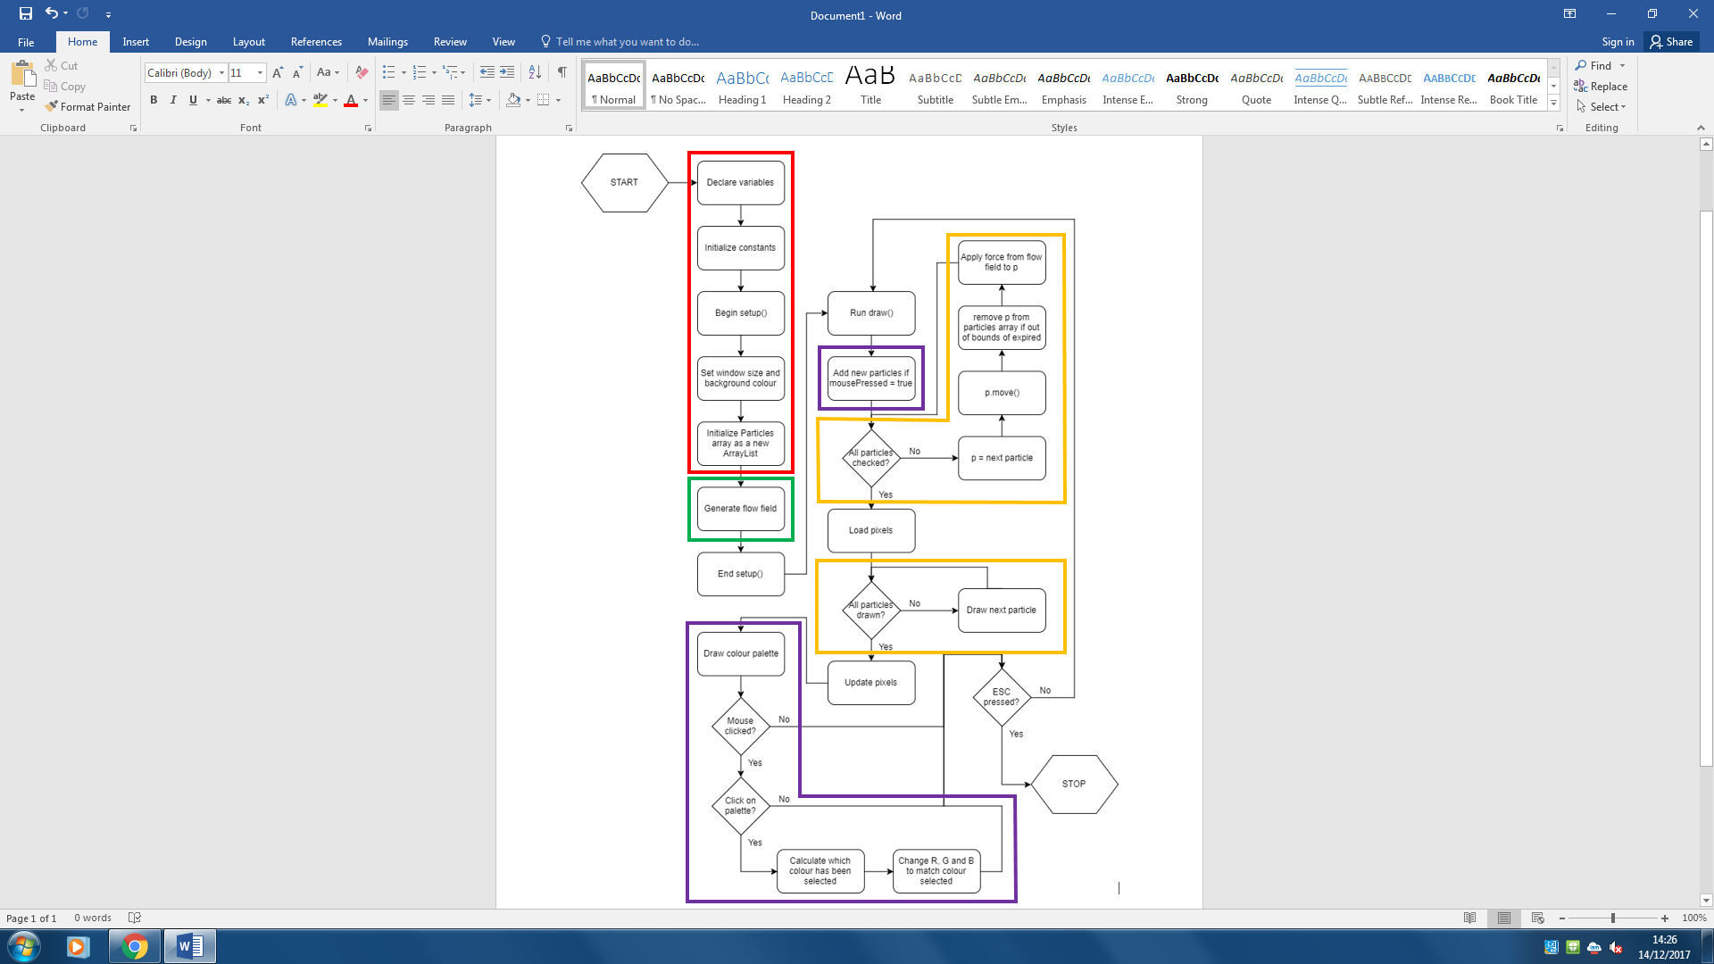

**Fig.4 - The complete design represented as a flowchart**

The design shown in figure 4 can be split into 4 parts, each of which represent a section of the code that serves a common purpose. I have highlighted each section using a colour that corresponds to a bullet point below:

1. **Setup** - This section involves the declaration of all global variables and the initialization of some of these, for example the size of each square in the grid of vectors, the dimensions of the canvas and the value of the variable that sets the size of the area of 2-dimensional Perlin Noise space being represented by the grid of vectors.
2. **Flow field generation** - This code will fill an array with a series of related vectors using the noise() function to create the base for the simulation.
3. **Event handling** - This can be split into two simple pieces of code: it will spawn particles into the simulation in the vicinity of the mouse if the mousePressed variable is found to be true. It will also calculate whether the location of the mouse click was on any of the “buttons” used for changing the colour that the particles will be drawn with.
4. **Particle handling** - This is the most important part of the program; it is what ties it all together. It will go through each particle one at a time, calculate which grid square the particle is in based on its position, then take the vector belonging to that grid square and apply it back to the particle as a force. This will also check if the particle’s lifespan has expired and if so remove it.

A fifth important section of code that does not have a place on the flowchart is the Particle class. The class needs a method for turning a force into acceleration, acceleration into velocity and taking that velocity and using it to plot the particle’s new position. There will also be methods for deciding how the particle will be drawn and for checking whether it has gone outside the bounds of the window so we know whether to remove it or not.

## Setup

Here is a table containing the constants that will be initialized to hardcoded values in the setup section:

|  |  |  |
| --- | --- | --- |
| **Name** | **Data type** | **Description** |
| Scale | Integer | The dimensions in pixels of each square of the flow field grid. Increasing its value will produce a flow field containing fewer vectors that will be less intricate. |
| Increment | Float | Will act as a coefficient for the variable that is passed into the noise() function. In practice it defines the distance along the Perlin Noise wave that will be traversed each time a new vector is generated. A smaller increment will mean traversing less distance along the perlin noise wave, resulting in the vectors being more closely related to the other vectors around them, giving a smoother, less turbulent flowfield. |
| r, g, b | Integer | The combination of these three variables determine the colour that particles will be drawn. For example when r = 5, g = 0, b = 0 means that any particle being drawn will increase the red component alone of the RGB value of any affected pixels by 5. |
| Density | Integer | This determines how many particles are spawned per frame while the mouse is held. |
| Speed | Float | This is the maximum number of pixels that a particle can travel in one frame. |
| Brightness | Integer | This is used as a coefficient for r, g and b when particles are drawn. A higher value will make the flow field become brighter faster. |
| TrailLength | Integer | This is the maximum lifespan of a particle in number of frames it can exist in the simulation for. Increasing its value will make longer wisps when the mouse is pressed. |

These constants are used to manipulate the way the way the simulation behaves and ultimately its aesthetics.

Here is a table of variables and objects which are declared at the beginning but initialised in the setup() function.

|  |  |  |
| --- | --- | --- |
| **Name** | **Data type** | **Description** |
| Rows | Integer | The number of rows in the flow field grid. Calculated by dividing the height of the widow by Scale. |
| Columns | Integer | The number of columns in the flow field grid. Calculated by dividing the width of the widow by Scale. |
| Particles | ArrayList<Particle> | This ArrayList stores all of the Particle objects that exist in the simulation. An ArrayList was chosen over a standard array because of its capability to resize. This is important because there is no set limit on the number of particles existing at once, meaning a stack overflow error would be possible with a |
| FlowField | PVector[][] | This array stores the vectors representing the force arrows of the flow field. |

The background will be drawn as plain black in this section. The fullScreen() function will also be called to ensure the window will fit to the size of whatever monitor it is run using..

## Flow field generationFlow field generation.jpg

**Fig.5 - Flow field generation algorithm**

**represented as a flow chart**

The algorithm shown in figure 5 iterates through a series of y values from 0 to the number of rows. For each y value it then iterates through a series of x values from 0 to the number of columns. For each combination of x and y values a new noise value will be generated with x and y as the two parameters, each of them multiplied by the increment variable.

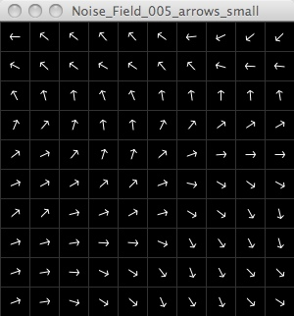

**Fig.6 - An example flow field**

Following the algorithm shown in figure 5 has the effect of generating a scalable 2-dimensional array of unit vectors where the direction of each vector is similar to the direction of the other vectors surrounding it. The resulting array of vectors can be seen in figure 6, drawn as a grid with an arrow in each square facing the same direction as the vector for the square:

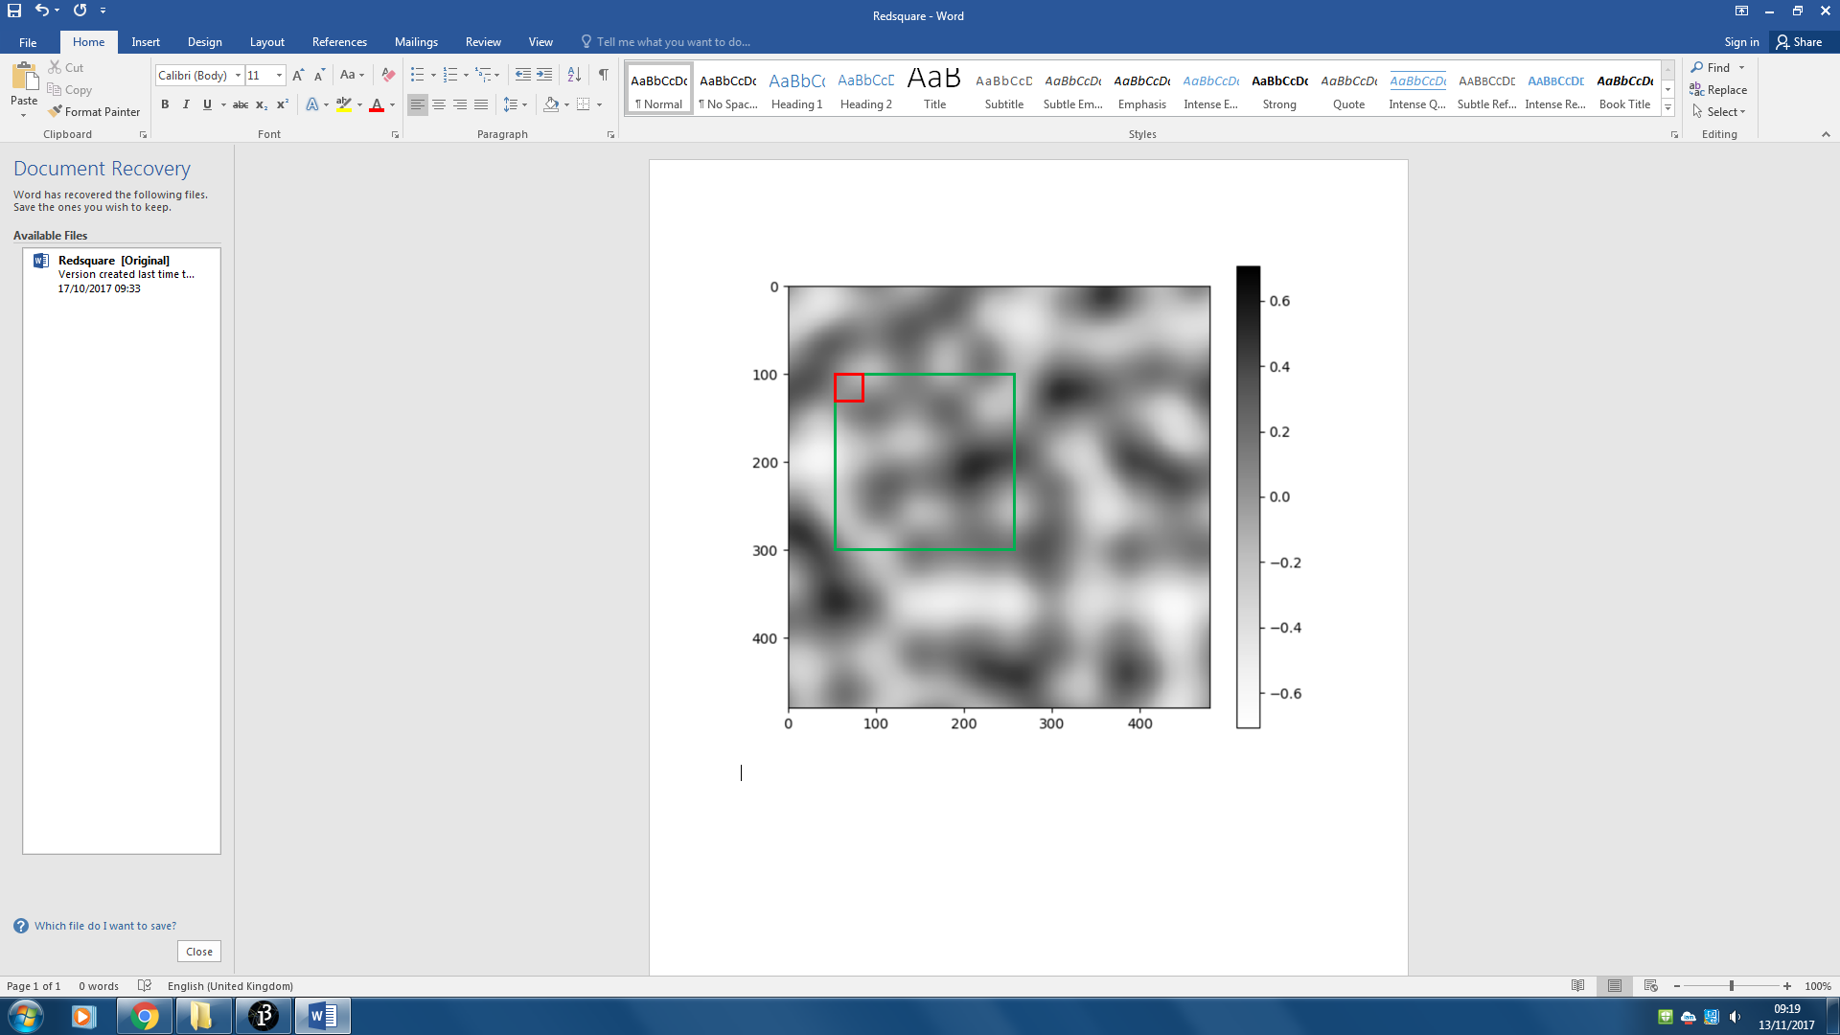

**Fig.7 - Sampling from the 2D noise plane**

In figure 7 the shade of each pixel represents the value returned when that pixel’s x and y coordinates are passed to the 2-dimensional noise function. The small red square represents one flow field grid square. The ‘increment’ variable governs the side length of the small square. Multiplying the ‘increment’ variable by ‘rows’ gives the side length of the large green square. By decreasing the ‘increment’ variable the size of both squares is decreased, resulting in a smaller area of Perlin Noise space being sampled. The result of this is that each small square will be closer to its neighbour, resulting in a smaller change between each consecutive returned value.

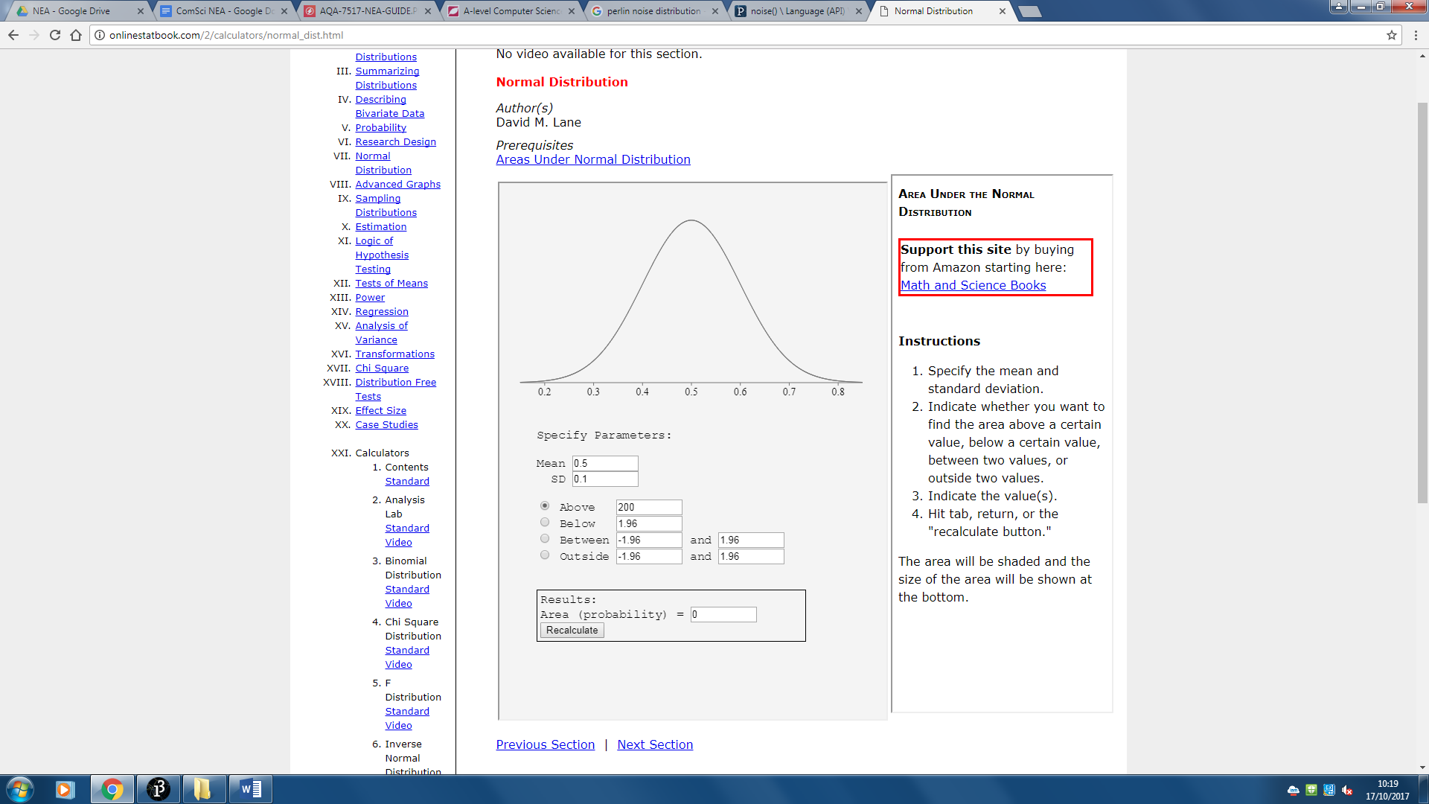

**Fig.8 - Distribution of the Perlin Noise function**

A sketch of the continuous probability distribution for the output of the Perlin Noise function is pictured in figure 8. The function outputs values between 0 and 1; due to the nature of the function, these values that are output are normally distributed with mean 0.5, as opposed to being distributed evenly between 0 and 1.

The “fromAngle” function that will be used to generate the vectors which takes a parameter in radians creates a new unit vector facing at that angle. You may assume that simply multiplying the Noise output by 2𝜋 would give a value suitable suitable to be passed to the “fromAngle” function. Upon running the program it would become apparent that every vector is facing downwards: some will be facing slightly left or slightly right but virtually none will be facing above the horizontal. This is because of the bias of the Perlin Noise function towards values surrounding 0.5. This means that the angle acquired when you multiply the Noise output by 2𝜋 will be biased towards values surrounding 𝜋.

## 

## 

## 

**Fig.9 - Zoom equation**

The aesthetics of the flow field that is generated depend wholly on the values of the constants SCALE and INCREMENT. The relationship between the two constants is described by the “zoom level” of the flow field, the equation for which is shown in figure 9. Two flow fields can have entirely different SCALE values but as long as long as the ratio between SCALE and INCREMENT (i.e. the zoom level) remains the same the size and shape of the waves in the flow field will be the same.

## Particle class

### Fields

|  |  |  |
| --- | --- | --- |
| **Name** | **Data type** | **Description** |
| Position | PVector | The vector can be resolved in each direction to give an x coordinate and a y coordinate. |
| Velocity | PVector | The vector can be resolved in each direction to give the number of pixels the particle will move in the x and y directions in the next frame. |
| Acceleration | PVector | This vector is added onto the velocity vector in each frame to change its speed and direction of movement based on the forces acting on the particle. |
| Lifespan | Integer | The number of frames the particle will exist in the world for before it is removed from the particles array. |
| AliveFor | Integer | Tracks the number of frames the particle has existed for so it can be compared to the value of Lifespan. |
| Limit | Float | The maximum speed the particle can travel i.e. the maximum magnitude of the Velocity vector. |

### Methods

|  |  |  |  |
| --- | --- | --- | --- |
| **Name** | **Return type** | **Parameters** | **Description** |
| Particle | Void | Int x, int y | This is the class’ constructor function. It will be responsible for initialising the Position vector using x and y values passed to it as parameters. It will also initialise the Velocity vector to have a random direction and magnitude and the Acceleration vector to have a direction and magnitude of 0. |
| Move | Void |  | This method handles the motion of the particle by modifying the position, velocity and acceleration vectors every frame. The acceleration is first added to the velocity which is then limited to a specific magnitude, then the velocity is added to the position then finally the acceleration is reset to 0 ready for a new force to be added to it in the next frame. |
| Show | Void |  | The particle will be drawn by darkening the single pixel at the x and y coordinates stored in the position vector. |
| ApplyForce | Void | PVector force | The force taken from the flowField array is passed to this method which then adds the force to the acceleration vector of the particle. |
| OutOfBounds | Boolean |  | This method returns true if the position vector is located outside the bounds of the canvas and returns false if it is not. |
| Expired | Boolean |  | This method returns true if the value of aliveFor exceeds that of lifespan. If aliveFor is not greater than lifespan aliveFor is incremented by 1 and false is returned. |

## Spawn particles

In the draw() function there will be an if statement with the condition mousePressed, the consequent code will add new particles to the particles array with positions equal to the position of the mouse cursor.

## Particle handling

The particle handling code will loop through every object in the particles array following a simple process for each particle:

* Call the Move() method of the particle.
* Check if the particle is out of bounds using the CheckOutOfBounds() method.
* If it is out of bounds remove the particle from the particles array and continue to the next iteration of the loop.
* Call the Draw() method of the particle.
* Calculate which grid square the particle is in by dividing the particles (x, y) components of the position vector by the scale variable.
* Obtain the force vector from the flowField array using the grid square coordinates of the particle as indexes.
* Pass the force vector to the ApplyForce method of the particle.

## HCI

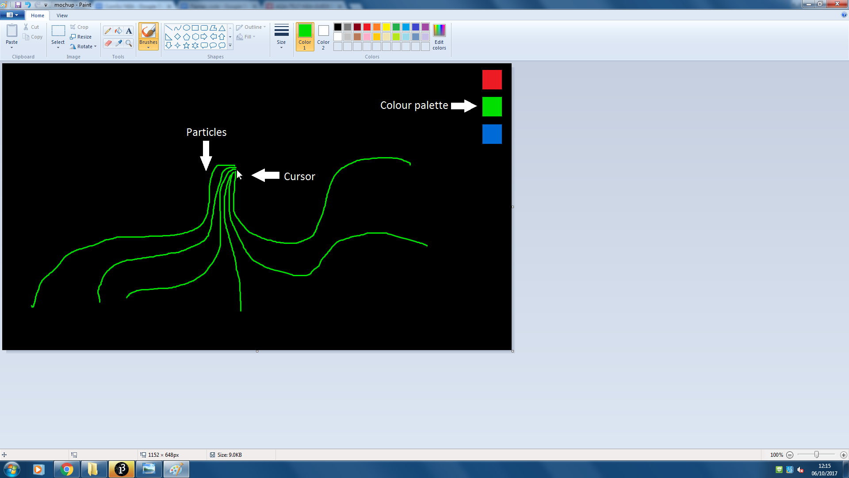

**Fig.10 - Design mockup**

The screen will start plain black apart from the palette. When a mouse button is held down particles will spawn at the location of the cursor and flow across the screen, leaving a faint trail behind them. As more particles travel across the same pixels they will gradually become brighter. The colour of the particles is changed with a single mouse click on the new desired colour in the palette.

An example of what this may appear like is shown in figure 9. It includes the colour selection palette and ‘tendrils’ splaying out from the location of the cursor. In the example green has been selected from the palette so the tendrils are green in colour.

# 

# 

# Technical solution

My technical solution has been constructed using the set of objectives I laid out in my analysis:

## Construct a grid of unit vectors. Each vector’s direction will be related to its neighbours’ by passing the coordinates of its grid square into the 2-dimensional Perlin Noise function. Each vector represents a force that will be applied to any particle located in its respective grid square.

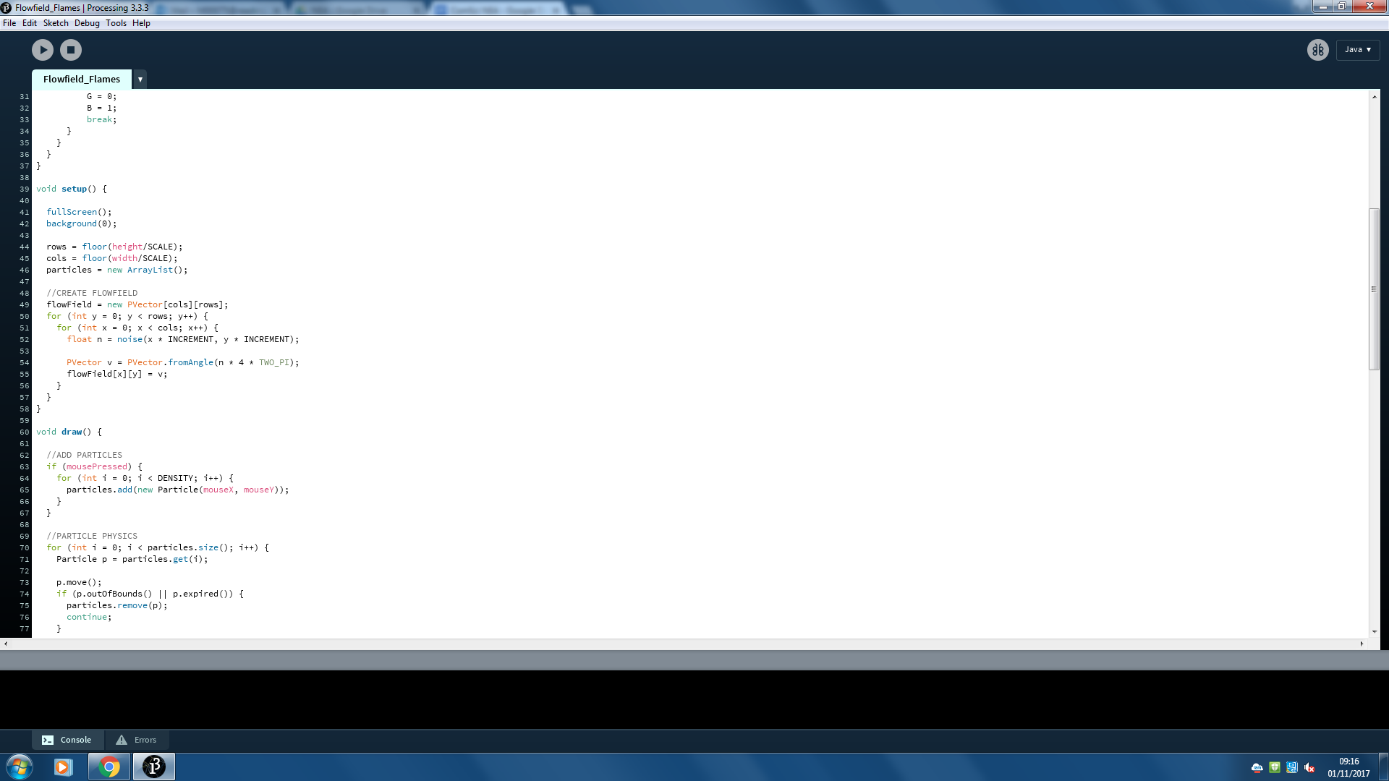

**Fig.11 - Generating the flow field**

By iterating through every column of the flowField and for each column iterating through every row it is ensured that a vector is assigned to each and every grid square. For each square a number is generated using the Perlin Noise function. The index of the row and column that are currently being targeted are used as the two parameters, multiplying them by INCREMENT makes the flowField scalable as explained in the design. The fromAngle function “Calculates and returns a new 2D unit vector from the specified angle value (in radians)”. To convert n, which is between 0 and 1, to a value in radians it is multiplied by 2𝜋. This value is then multiplied by 4 to distribute the resulting angles more evenly. The resulting PVector, v, is then saved in the flowField array at the current index.

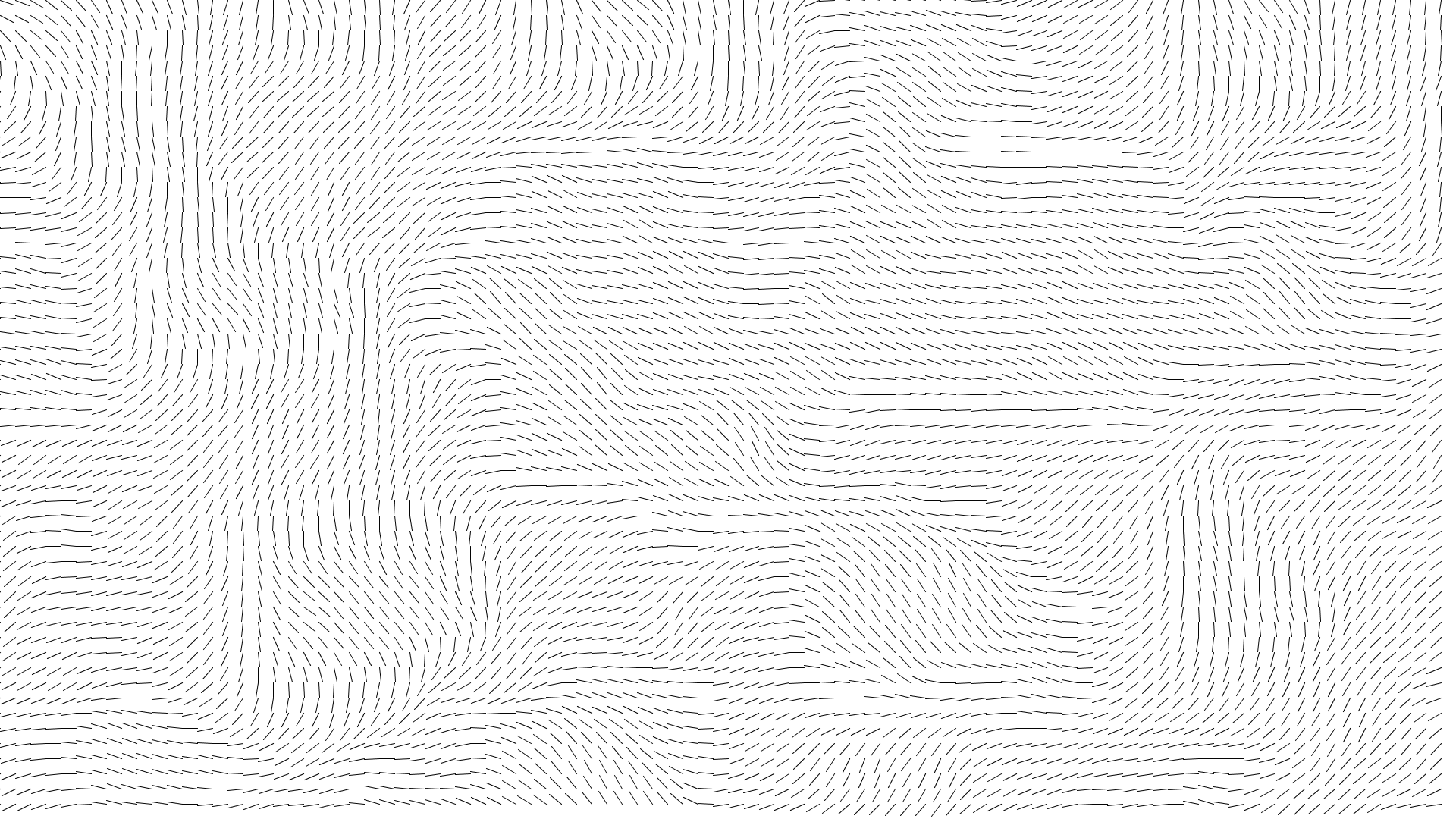

**Fig.12 - Flow field prototype**

Figure 11 is a screenshot from a prototype that draws a 10 pixel long line in each grid square that starts in the top left hand corner of the square and is drawn at the angle of its respective square’s PVector. If particles were to be dropped onto this flow field they would travel across the screen following the direction of the lines.

### 

### 

## Have a “Particle” object that is able to react to forces applied to itself using vector fields for position, velocity and acceleration.

The code for the particle class is pictured below:

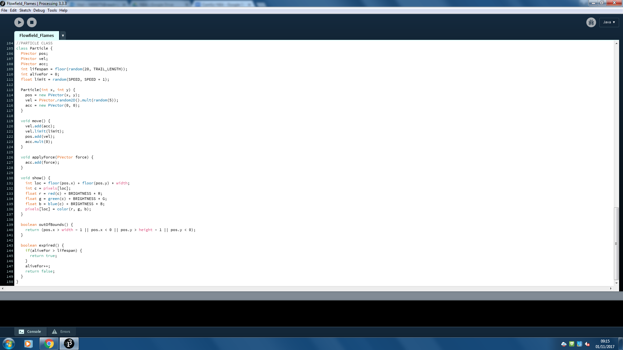

**Fig.13 - Particle class**

The apply force and move methods are responsible for the motion of the particle. They are pictured below:



**Fig.14 - Move() and ApplyForce() methods**

In line 120 the acceleration is first added to the velocity using standard vector addition rules. The velocity is then limited in line 121; the value of this limit is a random number between SPEED and SPEED + 1 determined when that particle was generated. Limiting a vector works by reducing the vector’s magnitude to be equal to the function’s parameter. The velocity is then added to the position to, in effect, move the particle by a number of pixels equal to the magnitude of velocity. Line 123 resets acceleration back to being a null vector so that a new force can be applied to it. If the acceleration was not reset every frame the particles would be less affected by new forces and would eventually end up travelling in the same direction indefinitely.

The apply force method adds a new force to the acceleration vector. Since acceleration has been made a null vector by this point already it simply has the effect of setting acceleration equal to this new force.

## Write a function that calculates which square of the grid each particle is located in before applying a force to the particle at the angle of the vector for that grid square.

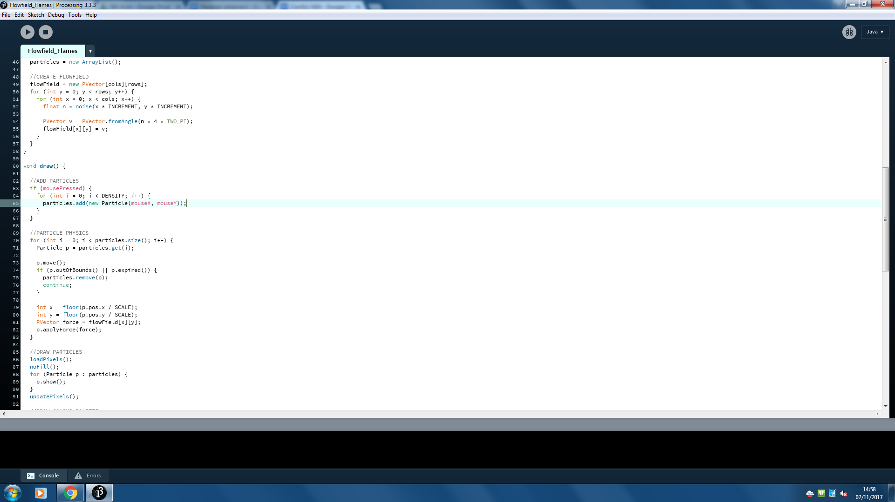

**Fig.15 - Moving, removing and applying forces**

**to particles**

This code loops through every particle in the particles array and for each carries out a series of processes:

* Call the particle’s move method to put the particle in its updated position.
* Check if the particle is located on the screen.
* If it is not, remove the particle from the particles array and continue to the next particle.
* If it is, calculate the row and column of the flow field grid that the particle is located in by dividing its x and y values by SCALE.
* Acquire the vector belonging to that square.
* Apply it to the particle by passing the vector to the particle’s applyForce method.

I would have liked to use an enhanced for loop to loop through the particles here but unfortunately it was not an option due to the possible removal of particles within the loop. You cannot remove objects from an arrayList you are currently looping through with an enhanced for loop in Java because the arrayList will become shorter but the loop will still run the same number of times meaning you will receive a null pointer error on the last iteration.

## Add a mouse listener function that, when a mouse button is held, spawns particles onto the canvas in the region of the cursor.

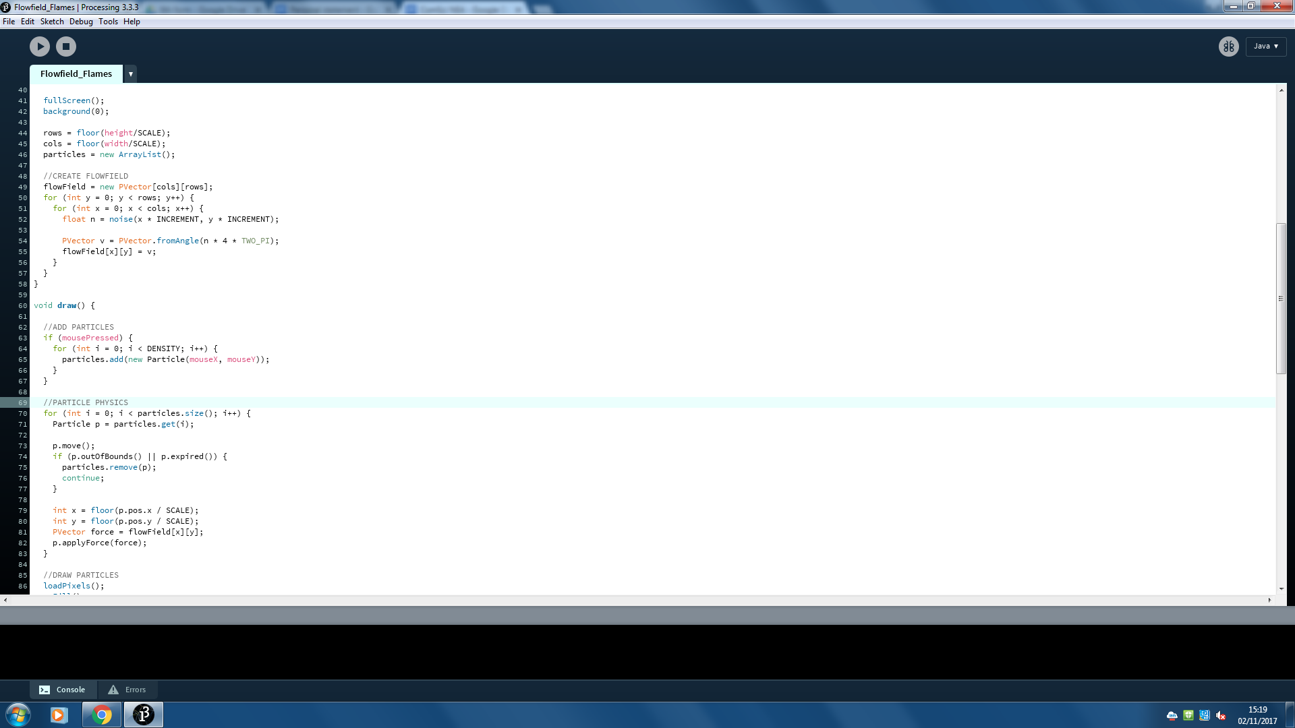

**Fig.16 - Adding new particles**

mousePressed is a boolean variable that is built into the Processing language. While any mouse buttons are held down it will be true, otherwise it will be false. By putting an if statement with mousePressed as its condition in the draw loop it is ensured that the consequent code will be run once for every frame when a mouse button is being held down.

Line 65 creates a new Particle, located at the (x, y) coordinates of the mouse, and adds it to the particles array. Line 64 ensures line 65 is run a number of times each frame that is equal to the value of the integer DENSITY. In practice this means “DENSITY” number of particles are generated at the location of the cursor in each frame.

### 

## Remove particles from the simulation that pass outside the edges of the canvas to improve the efficiency of the programme.

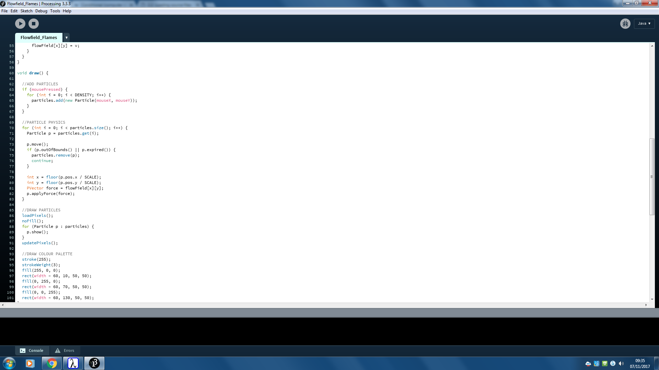

**Fig.17 - Removing particles**

An if statement in the particle handling loop checks, using their respective functions, whether the particle is out of bounds or has expired then removes the particle if either of them return true.

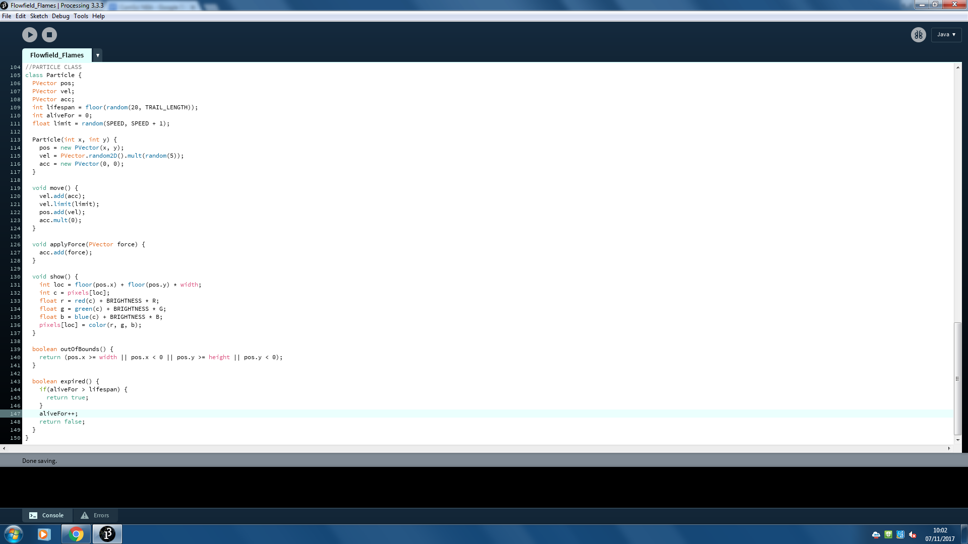

**Fig.18 - outOfBounds() method**

The “outOfBounds” method checks whether the particle is beyond any of the four edges of the window as follows:

1. **Right edge -** Is the x component of the position vector greater than the width of the window?
2. **Left edge -** Is the x component less than 0?
3. **Bottom edge -** Is the y component of the position vector greater than the height of the window?
4. **Top edge -** Is the y component less than 0?

These 4 boolean expressions are chained with OR operators before returning the resulting boolean. The OR operators have the effect of making the whole expression resolve to true if any single inner expression is true.

### 

### 

## Give all particles a “lifespan” field so when that set time elapses the particle is erased from the simulation.

As seen in the previous objective, lines 74-77 ensure any particle that any particle that's lifespan has expired will be removed from the simulation.

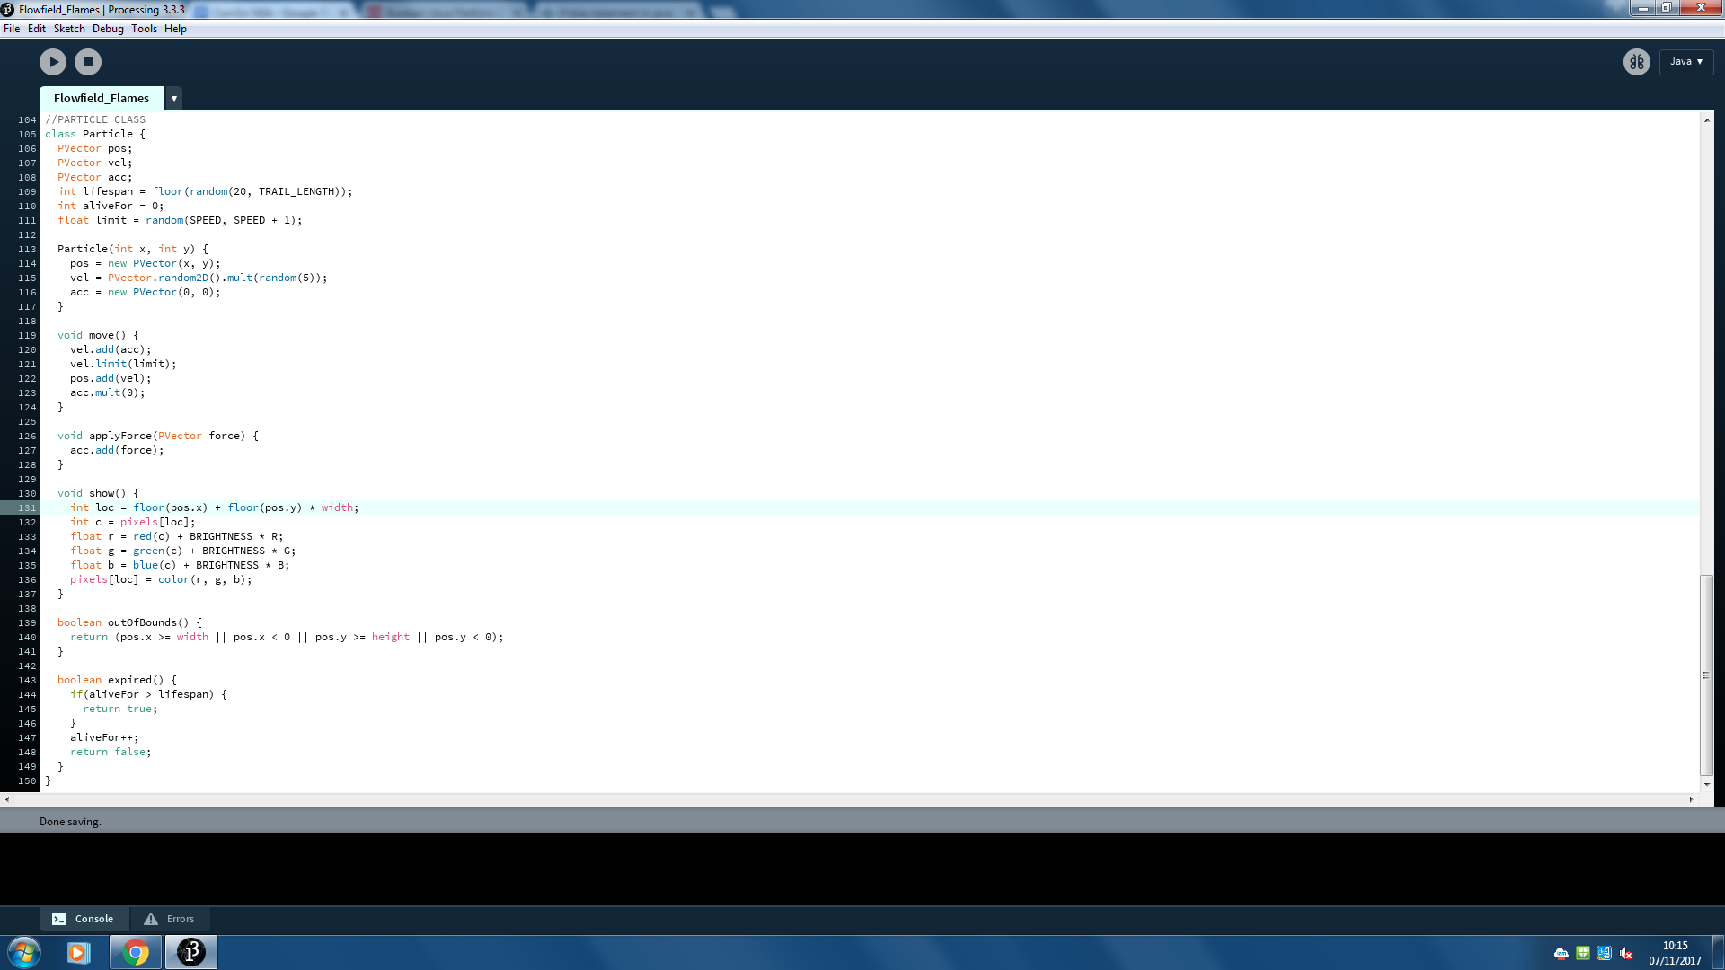

**Fig.19 - Expired() method**

The “expired” method returns the value of the boolean expression on line 144 that compares the number of frames the particle has existed for with the set lifespan of the particle. In addition, this method is also responsible for incrementing the value of “aliveFor”, given that the particles lifespan has not already been exceeded.

### 

### 

## Add a menu in the corner of the canvas that allows you to select the colour any new particles will be drawn as.

Implementing a colour palette involved two separate tasks:

1. Drawing the palette as a collection of coloured squares in one corner of the window.

The palette is drawn as 3 squares, each with side length 50 pixels. They are drawn with their left edge 60 pixels from the right edge of the screen, resulting in a 10 pixel gap between each square and the edge of the screen. The first square is drawn 10 pixels down from the top edge and each subsequent square is 60 pixels below the last, leaving a 10 pixel vertical gap between them. The first square is filled with block red, the second blue and the third green. They are each drawn with a 3 pixel white border to make them stand out from the background. The resulting palette looks similar to the prototype in figure 20.

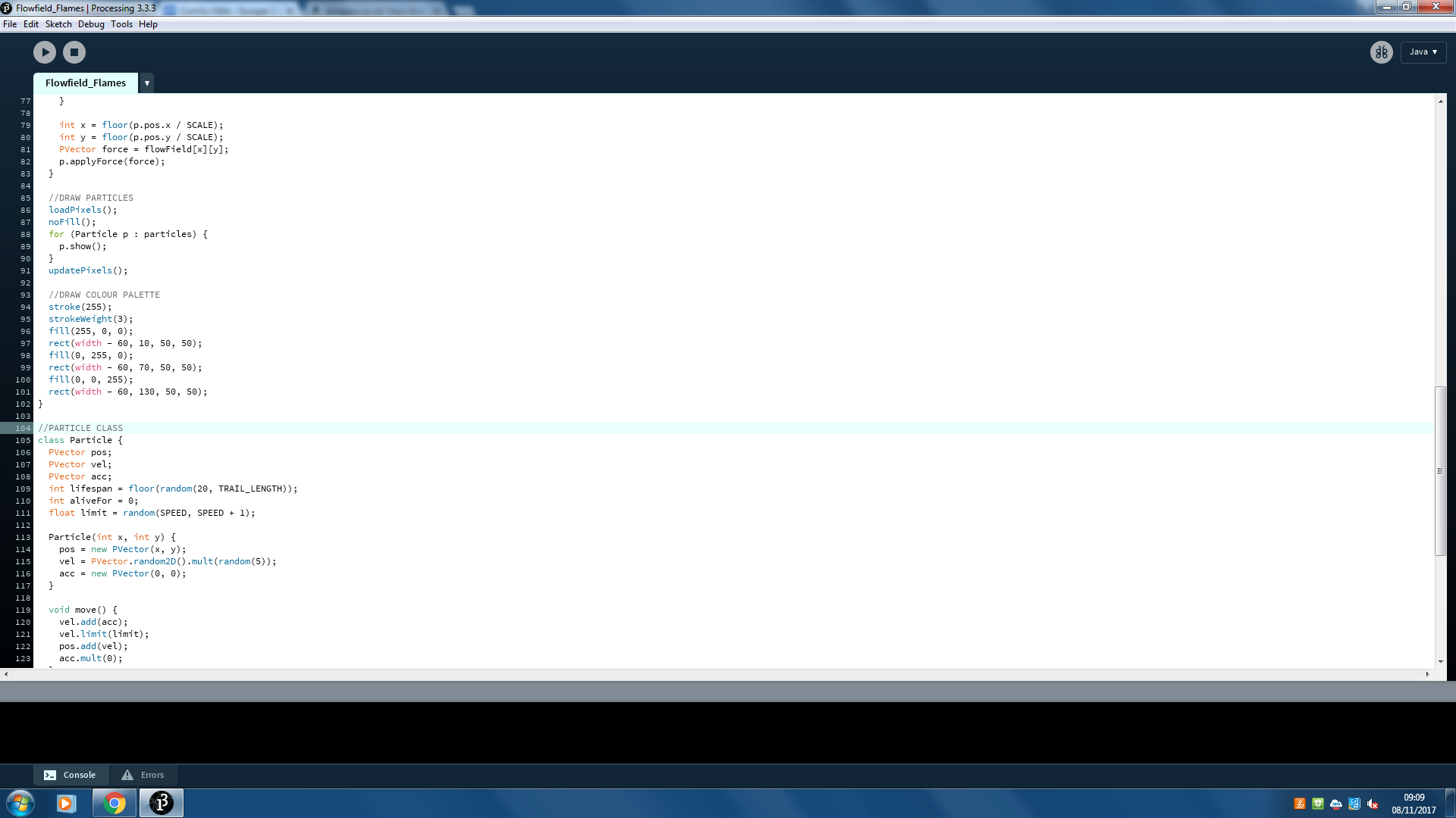

**Fig.20 - Drawing the colour palette**

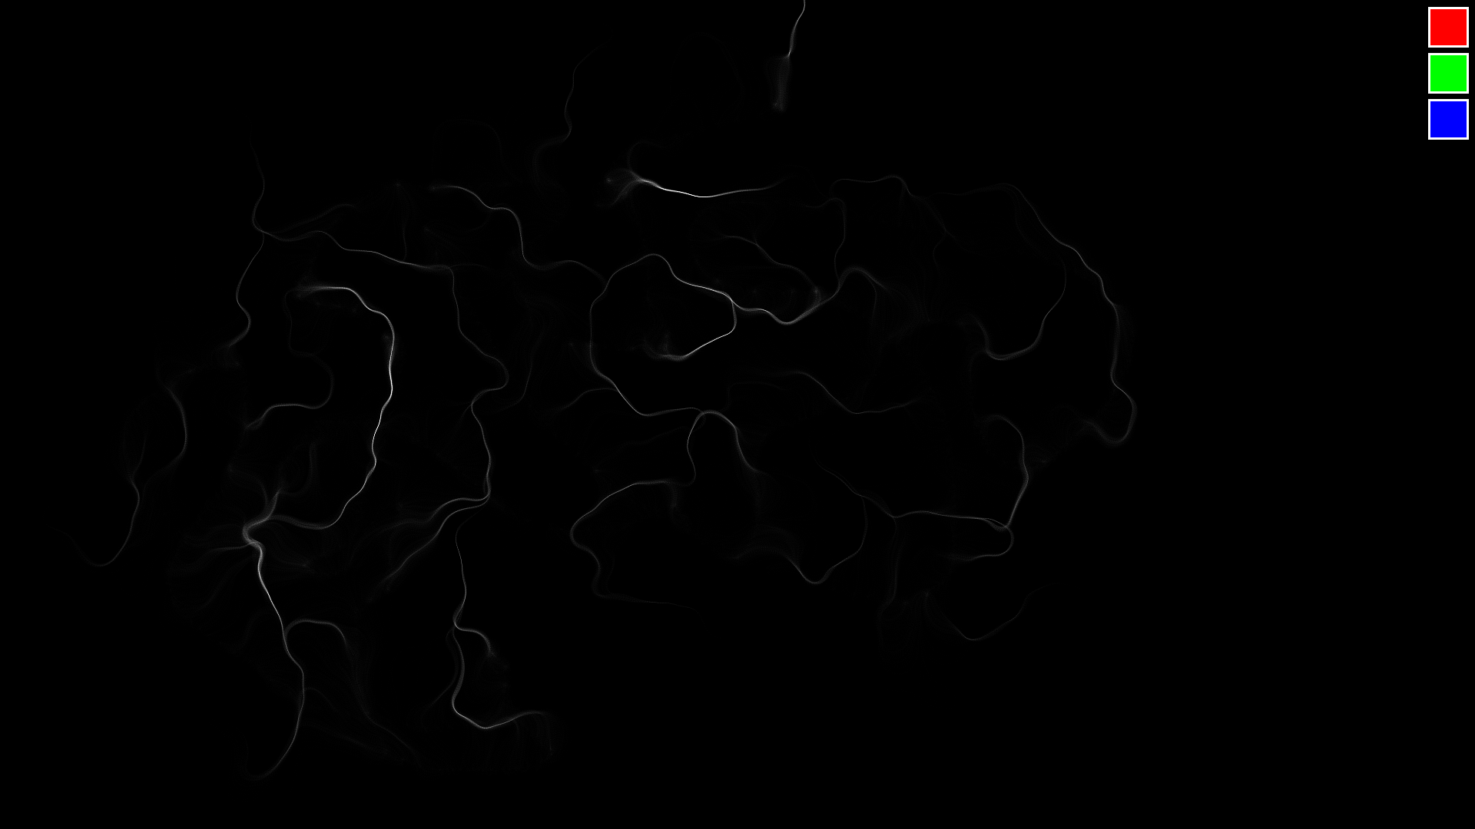

**Fig.21 - Colour palette prototype**

1. Monitoring any mouse clicks then taking the location of the pointer and using it to calculate which one of the colour selection buttons has been pressed so that the global variables R,G and B can be adjusted to match the colour of the relevant button.

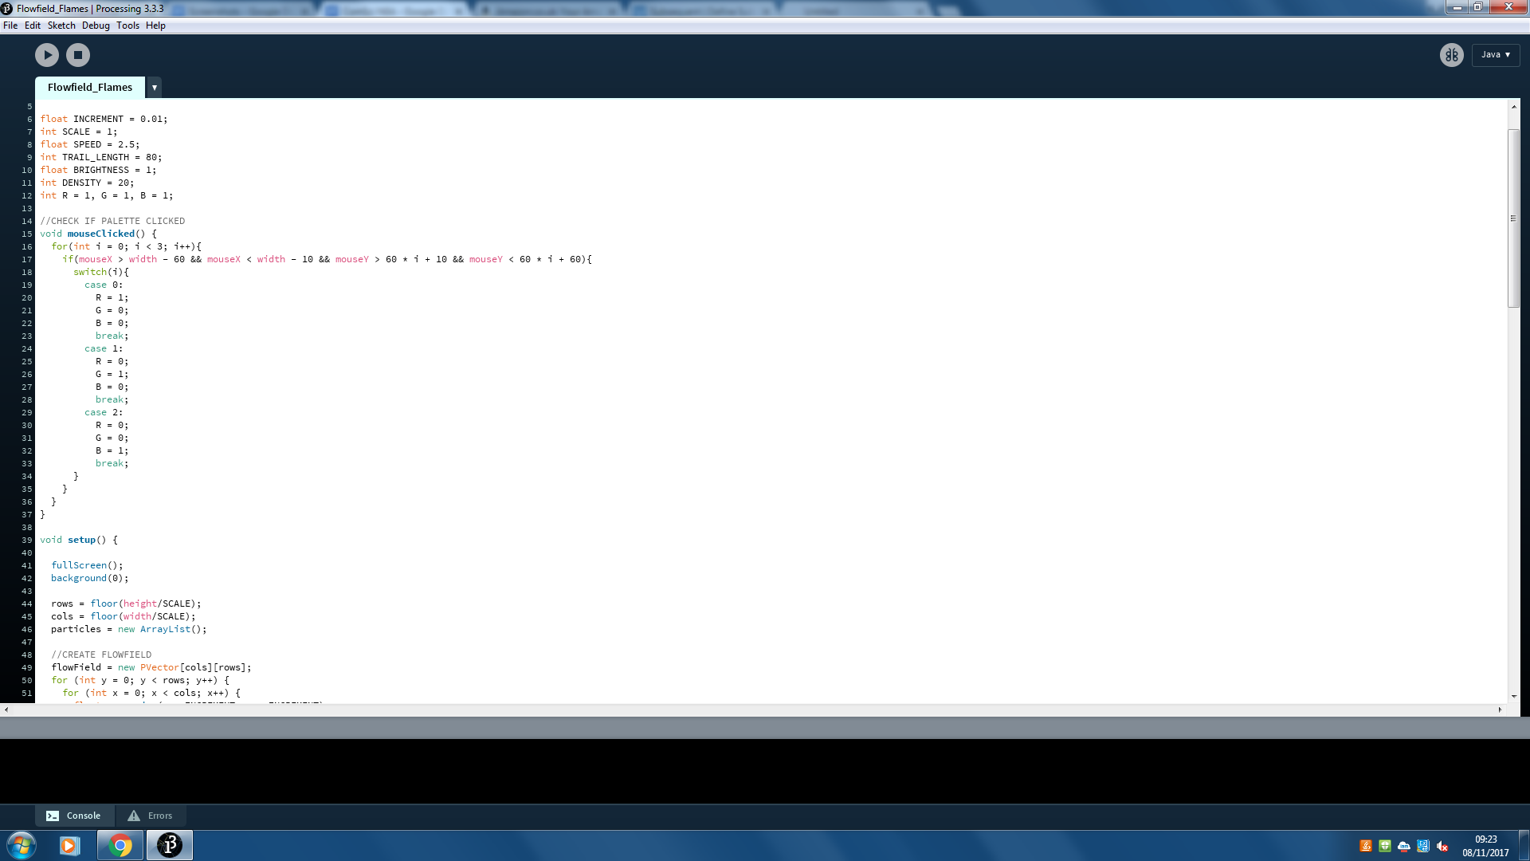

**Fig.22 - Calculating which colour has been selected**

I used a for loop on line 16 for a few reasons:

* Save on code - line 17 only needs to written once instead of having to write a new line to check each box individually.
* Expandable - if I decide to add more colours to the colour palette i would only need to change the condition of the for loop so it looped the same number of times as there are colour selection buttons.
* Ties in nicely with the switch statement in line 18 - instead of having to use a separate integer variable to store which button has been pressed I can just pass the value of i to the switch statement.

Lines 19-33 are responsible for changing the values of R,G and B so they match the colour of the button that was pressed.

## Change the way particles are drawn so the RGB value of the pixel where a particle is located is incremented by only a small amount, as opposed to changing the pixel to a block colour, to give the visual effect of the screen slowly becoming brighter in areas where more particles pass.

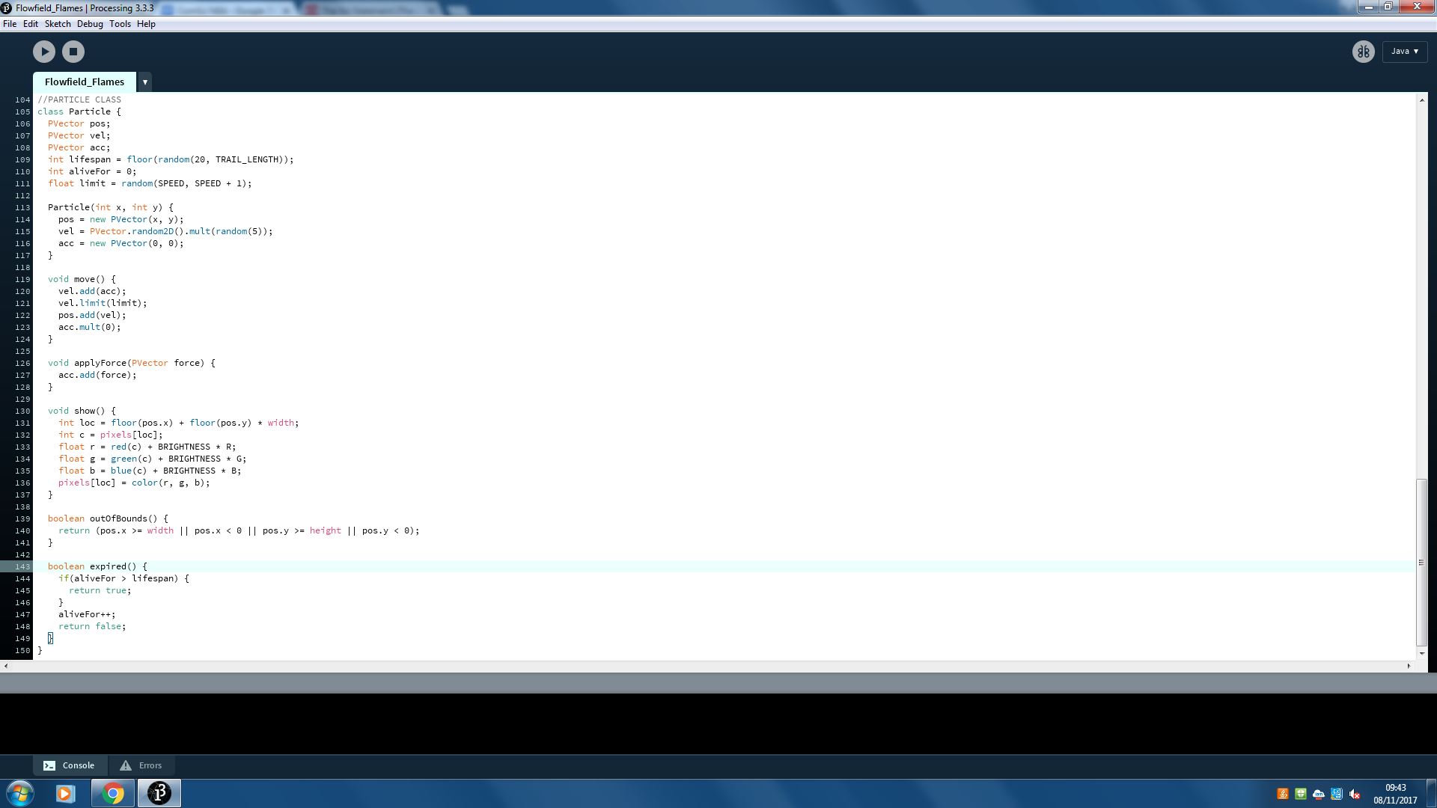

**Fig.23 - Show() method**

The show method is responsible for displaying the particle on the canvas. The code responsible for displaying the particles is located in the draw function. It works by loading the canvas’ pixels, modifying them using the particles’ show method then finally updating the pixels as shown:

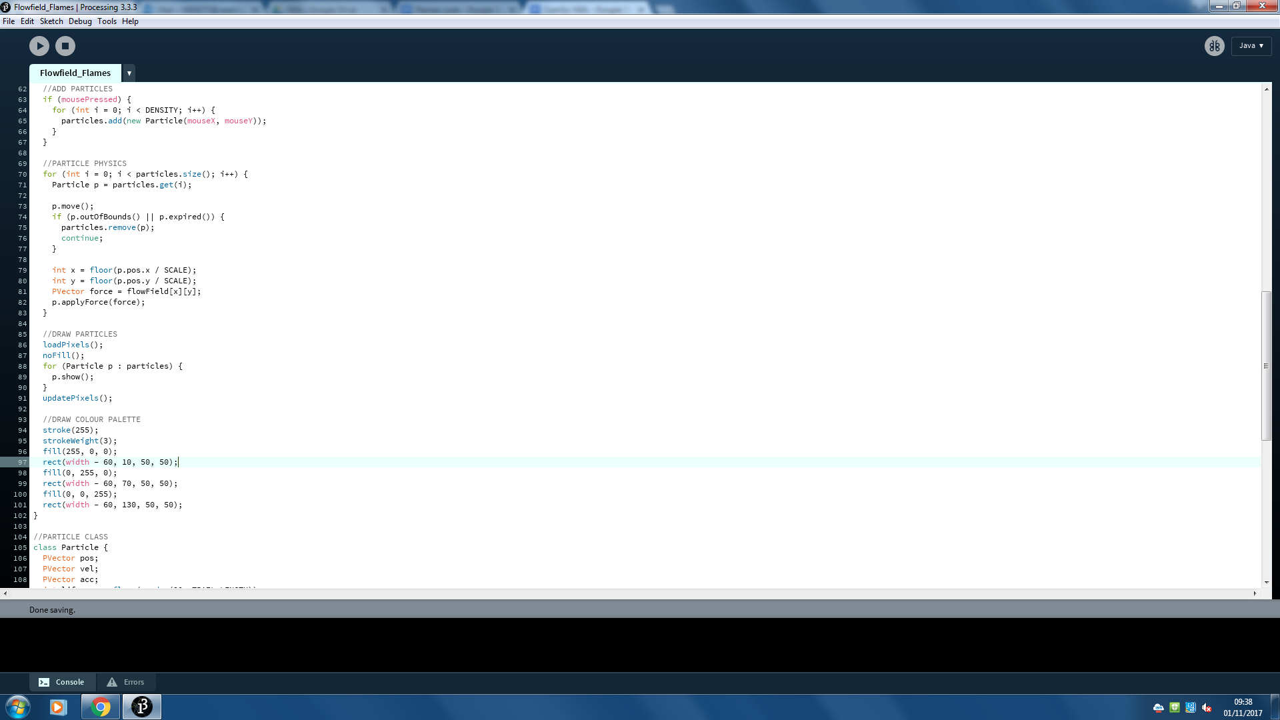

**Fig.24 - Drawing each particle by editing**

**the pixels array**

On line 131 I calculate an index using this formula which is then used on the following line to access the RGB value of the desired pixel from the pixels array. On lines 133-135 the red, green and blue parts that make up the colour of the pixel are separated so their brightness can be increased independently. The same element in the pixels array is then updated with the new colour created using the three new values for red, green and blue.

The following section of the technical solution is devoted to any areas of the solution which are not encompassed by the objectives of the project.

## Randomising particle attributes:

When writing the loop that is responsible for spawning multiple particles per frame (lines 61-66) I came across an issue: without any randomness involved in the creation of particles any particles that are generated in the same frame would follow the exact same path at the exact same time, essentially coalescing to appear as one particle. I decided to add some randomness to the life span, speed limit and initial direction of motion of the particles so that they can spread out and generate a more interesting pattern.

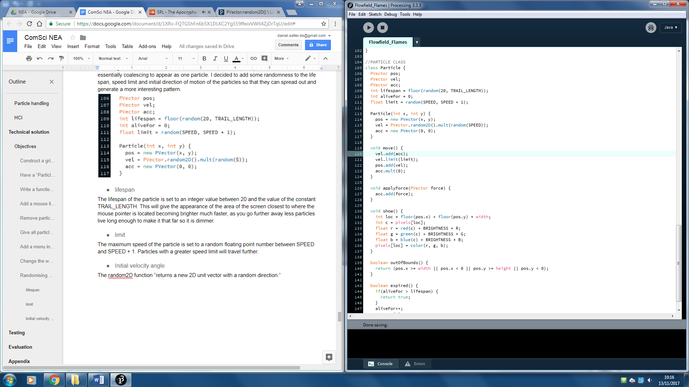

**Fig.25 - Particle object fields and constructor**

### lifespan

The lifespan of the particle is set to an integer value between 20 and the value of the constant TRAIL_LENGTH. This will give the appearance of the area of the screen closest to where the cursor is located becoming brighter much faster, as you go further away less particles live long enough to make it that far so it is dimmer.

### limit

The maximum speed of the particle is set to a random floating point number between SPEED and SPEED + 1. Particles with a greater speed limit will travel further.

### Initial velocity

The random2D() function “returns a new 2D unit vector with a random direction.” The new vector created is a unit vector, meaning it has a magnitude of 1. The magnitude of the vector is then multiplied by a random number between 0 and SPEED to ensure the particles are not all travelling at the same speed when they are spawned.

## Band A technical skills:

I have listed below all the band A technical skills I have used in my code and provided examples for each:

### Hash tables, lists, stacks, queues, graphs, trees or structures of equivalent standard

On line 4 an ArrayList that stores Particle objects is declared with the name particles. I used this ArrayList to store every particle that exists in the simulation. I chose to use an ArrayList for its properties as a dynamic data structure: being able to readily add and remove particles from anywhere in the array at any point in time was a necessity.

### List operations

On line 49 the particles ArrayList is initialised as a new, empty ArrayList. This is done using the default ArrayList constructor function.

On line 68 a new Particle is added to the particles ArrayList using the add() function.

On line 74 a Particle is returned from the particles ArrayList by passing the index of the desired particle to the get() function.

On line 80 a Particle is removed from the particles ArrayList my passing the desired particle to the remove() function.

On line 94 an enhanced for loop has been used to iterate through the entire contents of the particles ArrayList.

### Complex user-defined use of object oriented programming (OOP) model, eg classes, inheritance, composition, polymorphism, interfaces

The Particle class is defined from line 111 to line 161. The class consists of several fields, a parameterized constructor function and several methods: some methods are void while others return values, some take parameters while others do not.

### Dynamic generation of objects based on complex user-defined use of OOP model

On line 68 a new Particle object is created. As seen on line 66 this is only done when mousePressed is true (when a mouse button is held). The x and y-coordinates of the mouse are passed to the Particle’s constructor function which then initialises the particle’s position vector using those same two values.

### Complex scientific/mathematical/robotics/ control/business model

In my program I have used a rudimentary physics engine to simulate a light particle having forces applied to it while under the influence of a limiting resistance. The calculations required to make this happen take place in the move() method of the Particle class between lines 126 and 131.

# 

# 

# Testing

I have tested the functionality of my program using a series of questions. I will predict the outcome of each test before carrying it out; if the outcome meets the prediction the test can be considered a success, if not it is a failure. A table summarising the outcomes of all the tests can found following test number 7.

Further to these tests I found it necessary to investigate both the effect of altering the values of the constants initialised at the beginning of the program and the position of the background() function within the code. For each constant I have outlined several possible values then provided evidence of the effect the alteration has had.

I have made an effort to provide as much evidence as possible in this section. For the most part this is provided in the form of screenshots but as my program is a dynamic simulation recording some footage of the program in operation was necessary to showcase every aspect of the code. I initially tried using OBS to record directly what was being displayed on my monitor, however I came across an issue where the footage was extremely choppy. It transpired that my computer was not powerful enough to run both the recording software and the flow field program at the same time at full 60fps. To overcome this I have recorded footage on my mobile phone where applicable and edited the clips into a single video which I will refer to at certain points throughout the testing process using time stamps.

Video URL:

https://youtu.be/Kl-RGXfwRME

## Does the flow field generation algorithm work when the random() function is used to generate the vectors?

I am expecting the screen to be filled with arrows pointing in totally random directions; there should be no relationship between the angles of neighbouring vectors.

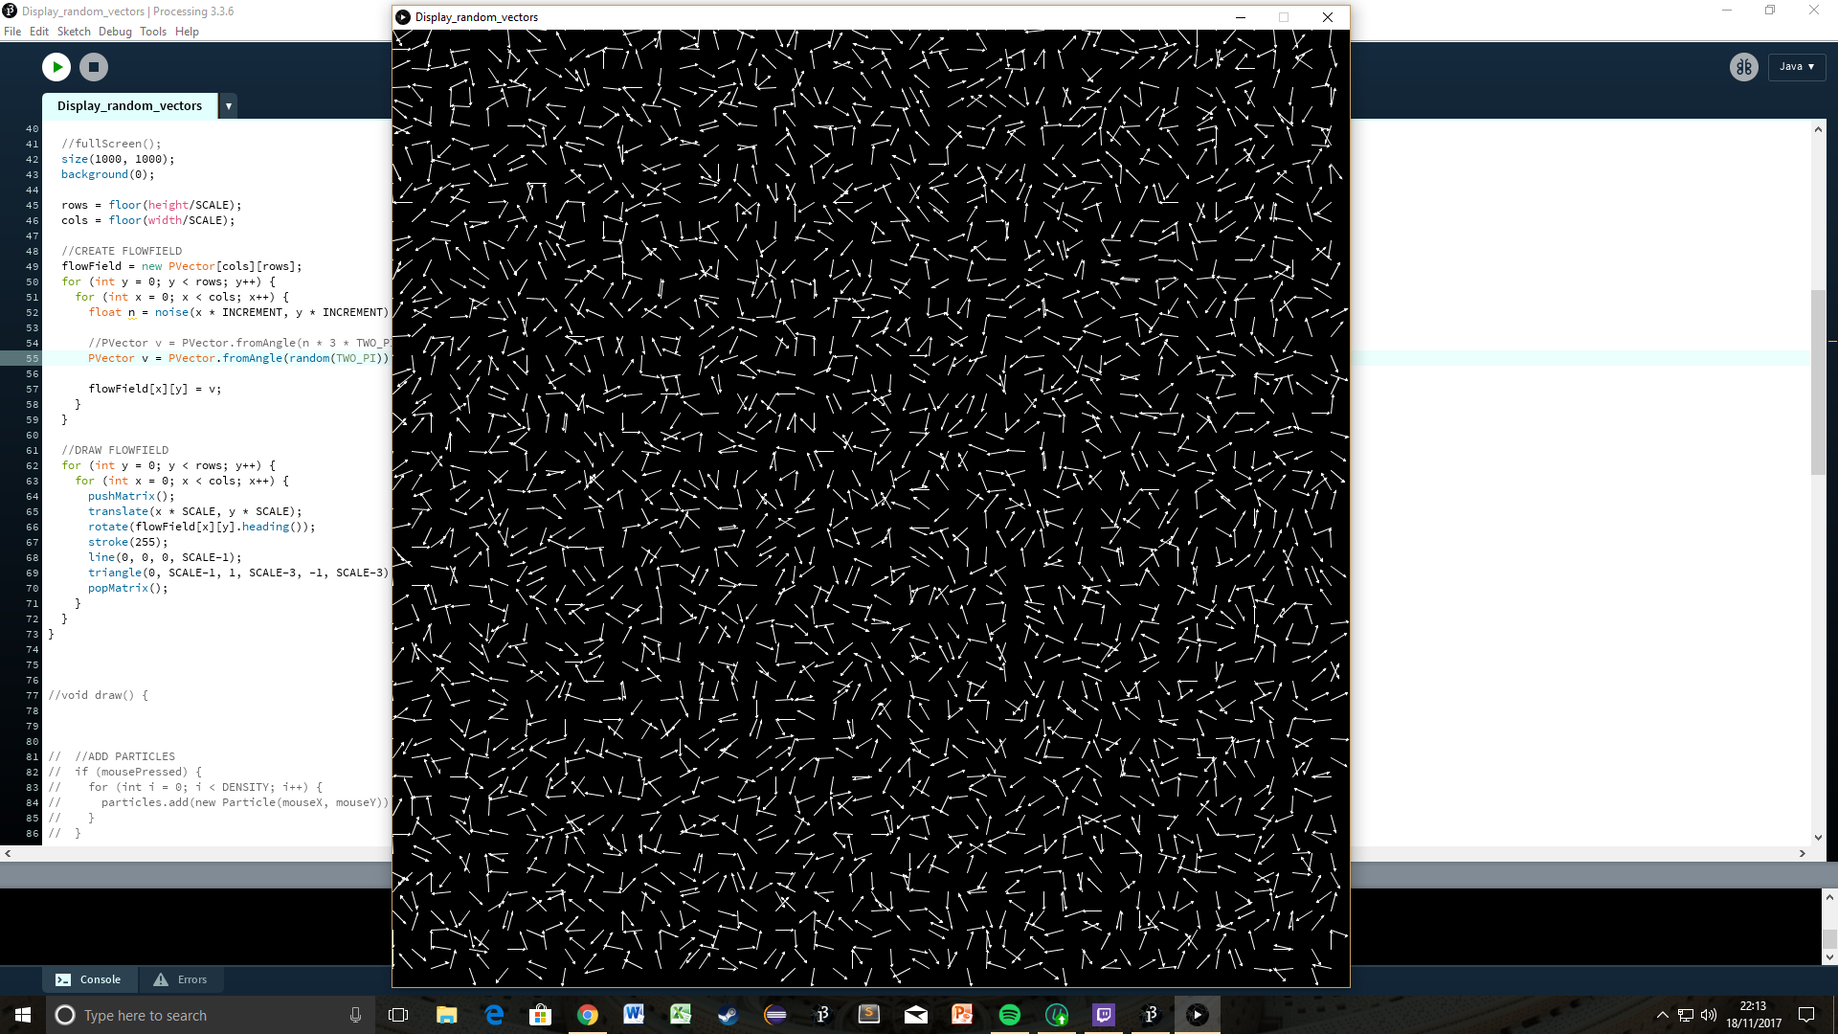

**Fig.26 - A grid of unrelated, random vectors**

Figure 25 displays a grid of points with an arrow extending from each. The arrows represent unit vectors which were initialized using angles generated by the random function. Generating the flow field in this way yields a grid of completely unrelated vectors. This is what was expected so the algorithm passed this test.

## Does the flow field generation algorithm work when the noise() function is used to generate the vectors?

Changing the code so vectors are now generated using the noise() function instead of the random() function should change the simulation from appearing as a grid of totally random arrows to a flow field where each vector is related to its neighbours.

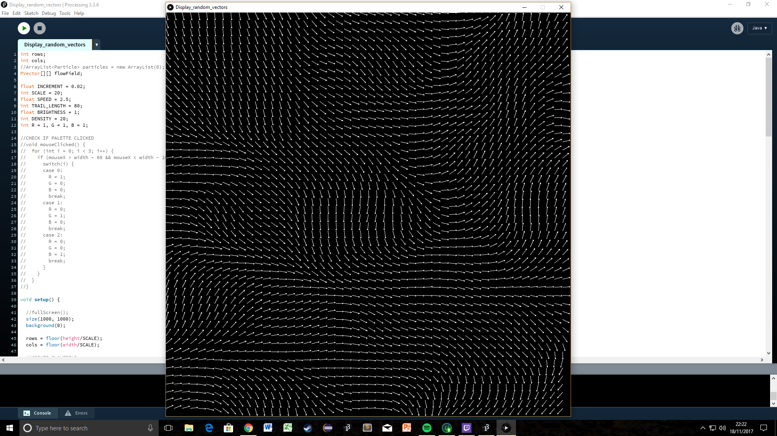

**Fig.27 - Flow field: Example a**

The effect of this alteration to the flow field generation algorithm is evident when figures 25 and 26 are compared. As expected the arrows are now related to their neighbours, giving the effect of a gradual change of direction as you traverse the canvas. This was as predicted so the program passed this test.

## Do particles added to the simulation follow the direction of the flow field?

It is expected that particles will enter the simulation with a random velocity before being pushed in the direction of the arrows around it.

Shown from 0:00-0:15. Every particle followed the direction of the lines surrounding it until it passed off the screen. This was as expected so the test was a pass.

## Are particles removed from the simulation upon exiting the window?

It is expected that particles are removed between the last frame it is drawn on screen and the first frame it would have been drawn off screen to avoid a NullPointerException.

Shown from 0:15-0:28. On the left of the screen is a log displaying the number of particles existing in the simulation in any one frame. It is clear that when the mouse is held more particles are added leading this number to increase and that as particles travel off the screen they are removed leading the number to subsequently decrease again until eventually returning to 0. This was as expected so this test was a pass.

## Are particles removed from the simulation when they have exceeded their set lifespan?

It is expected that particles are removed from the simulation when they have existed for a greater number of frames than the number defined by their lifespan.

Shown from 0:28-0:42. Particles clearly disappear before reaching the edge of the screen. This was as expected so this test is a pass.

## Are particles given a random velocity when they are spawned?

It is expected that when particles are spawned their velocity is random in terms of both magnitude and direction. This will mean they spread out in every direction in the first few frames after being spawned preventing them from travelling on top of one another.

Shown from 0:42-0:50. After setting SCALE to be 100 it is easy to see the particles spreading out in every direction in the first instant after being spawned. This is due to the random velocity each particle is given when it is created. This was as expected so the program passed this test.

## Are new particles drawn with the intended colour after after a new colour is selected using the palette?

It is expected that every particle spawned after a new colour is selected from the palette is drawn using that colour.

Shown from 0:50-1:20. In this clip I demonstrate drawing using all four colours available in the simulation: first the default white, then blue, then green and finally red. I was able to switch between these colours with a single click on the desired colour’s square in the palette. After selecting a new colour all newly spawned particles are drawn with that colour. This was as expected so the program passed this test.

|  |  |  |
| --- | --- | --- |
| Test number | Description | Pass/Fail |
| 1 | Does the flow field generation algorithm work when the random() function is used to generate the vectors? | Pass |
| 2 | Does the flow field generation algorithm work when the noise() function is used to generate the vectors? | Pass |
| 3 | Do particles added to the simulation follow the direction of the flow field? | Pass |
| 4 | Are particles removed from the simulation upon exiting the window? | Pass |
| 5 | Are particles removed from the simulation when they have exceeded their set lifespan? | Pass |
| 6 | Are particles given a random velocity when they are spawned? | Pass |
| 7 | Are new particles drawn with the intended colour after after a new colour is selected using the palette? | Pass |

## Testing the effect of changing the placement of the background():

### When background() is in the draw() function

Shown from 1:20-1:25. When the background function is called each frame the previous position of particles are wiped from the canvas. This results in particles leaving no trails behind them as they move.

### When background() is in the setup() function

Shown from 1:25-1:34. Moving the background function to the setup() function prevents the canvas from being wiped each frame. All the previous positions of particles remain visible particles leaving trails behind them. This effect appears as tendrils extending from the location of the cursor when the mouse button is held.

## Testing the effect of changing the values of the constants initialised at the beginning of the program:

### Scale

#### When SCALE = 100, INCREMENT = 0.1 (zoom x1000)

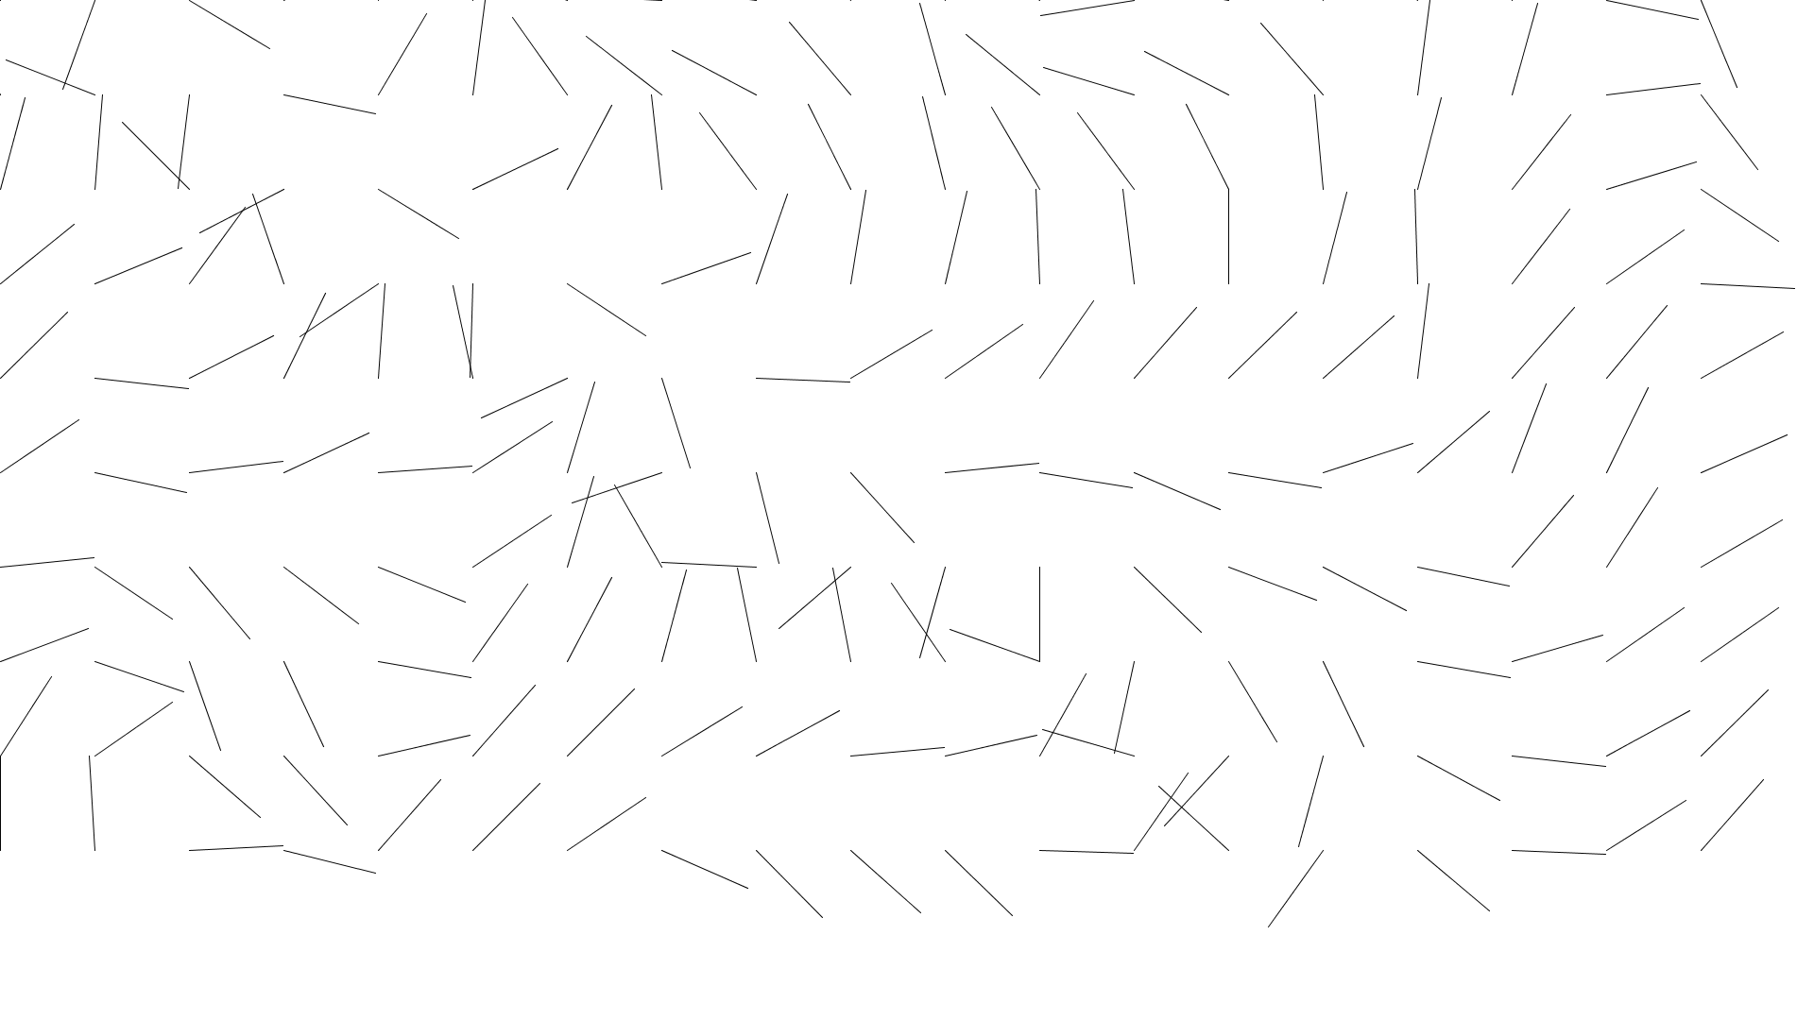

**Fig.28 - Flow: Example b**

The relationship between neighbouring vectors is hard to see when the SCALE is set to such a large value with a zoom level of 1000x. If the flow field was more zoomed in it would be far easier to see the relationship.

#### When SCALE = 20, INCREMENT = 0.02 (zoom x1000)

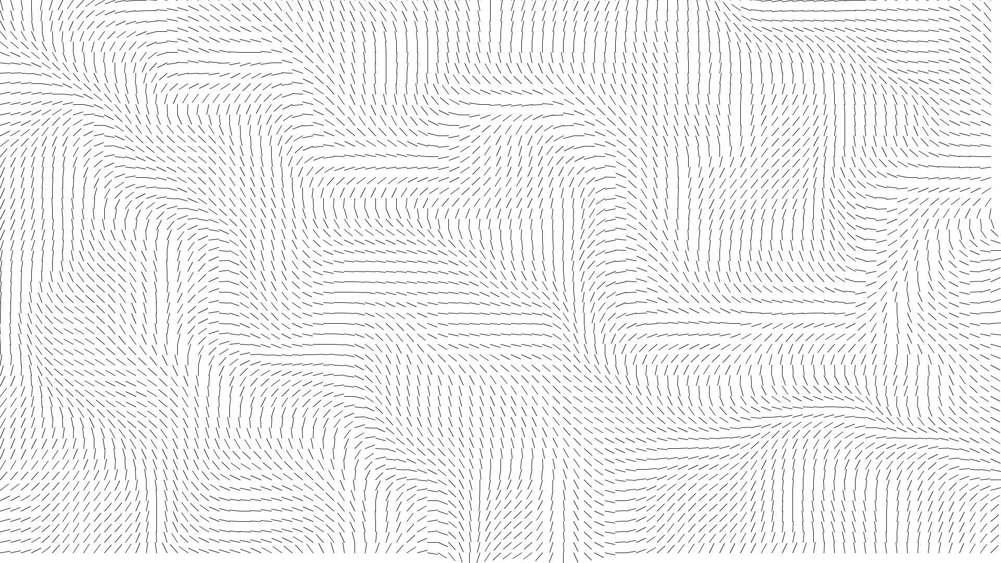

**Fig.29 - Flow field: Example c**

The most obvious change made by reducing the value of SCALE is that there are now a far greater number of smaller lines on screen. Since SCALE has been divided by 5, in order to keep the zoom level the same, INCREMENT has been divide by 5 as well. It may be difficult to see here but the size and shape of the undulations that exist within the flow field have remained the same between figures 27 and 28. This is a result of retaining the same zoom level.

#### When SCALE = 1, INCREMENT = 0.001 (zoom x1000)

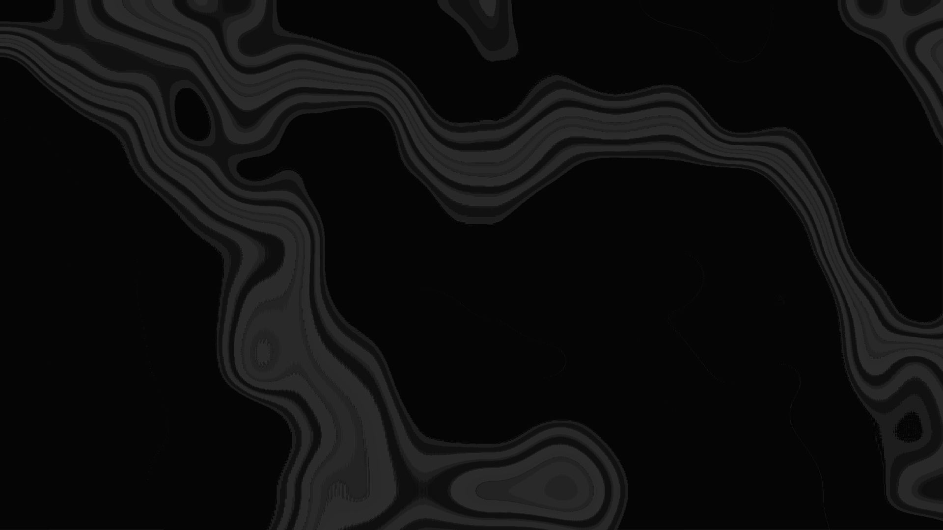

**Fig.30 - Flow field: Example d**

Decreasing the value of SCALE to 1 has yielded a very interesting visual result. The screen is now covered with some kind of ghostly contours. Although this may not be visually appealing it does not matter as the code will not ordinarily draw the flowfield onto the screen. Again, it may not be easy to see but since the zoom level has remained the same so has the size of the undulations amongst the vectors.

After examining these results I have decided to use a SCALE of 1. 1 vector per pixel is the greatest level of detail available to me so will generate the most interesting flow field.

### INCREMENT

In these examples I have kept the value of SCALE constant at 5 so the effect changing the value of INCREMENT has on the “zoom” level of the flow field can be easily visualised. In figures 30-32 a 5 pixel long line has

#### When SCALE = 5, INCREMENT = 0.005 (zoom x1000)

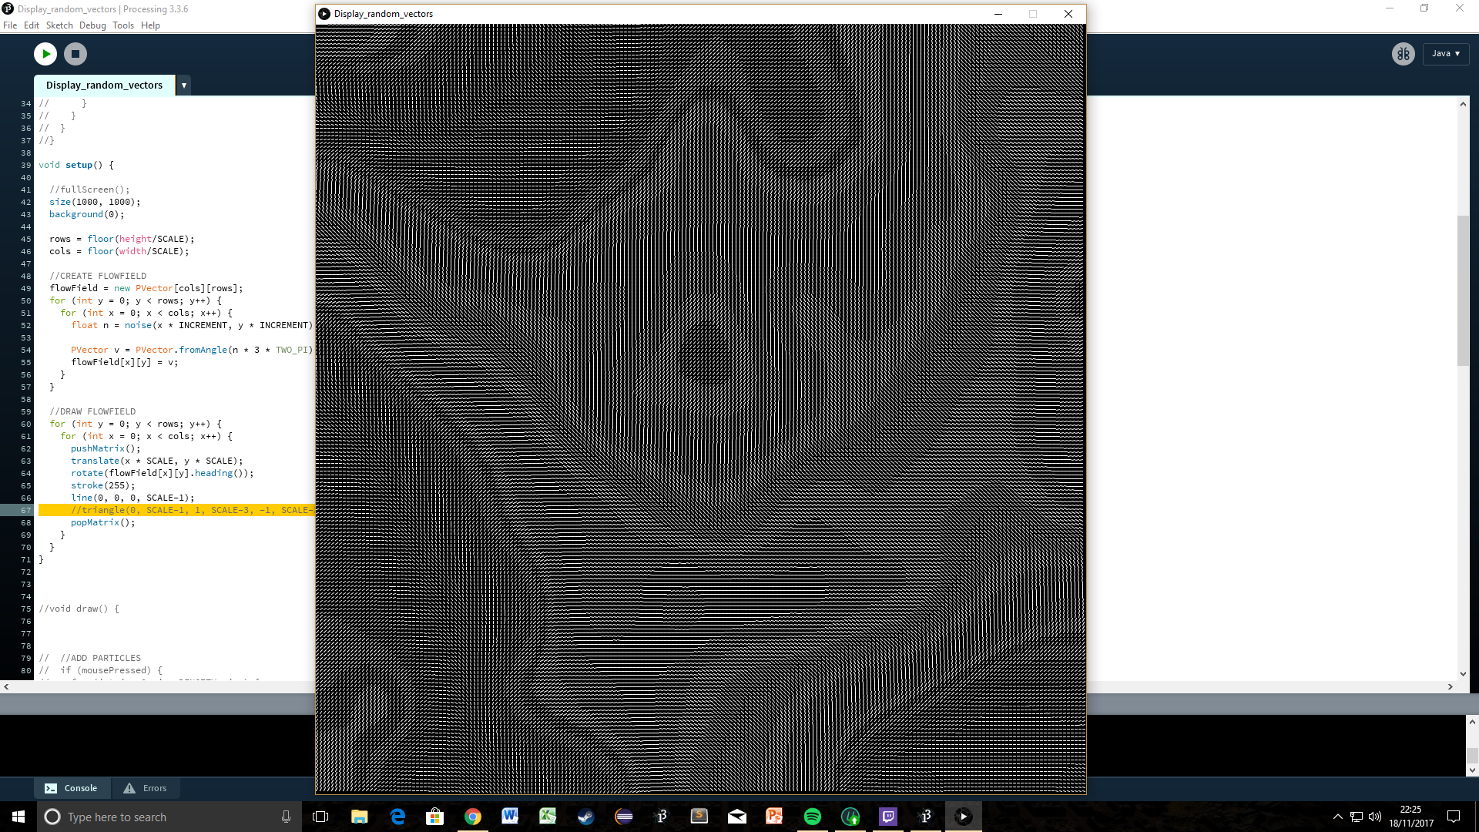

**Fig.31 - Flow field: Example e**

#### When SCALE = 5, INCREMENT = 0.025 (zoom x200)

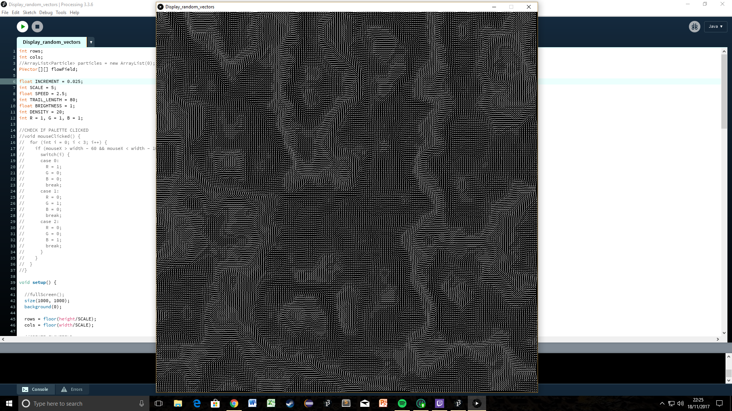

**Fig.32 - Flow field: Example f**

From figure 27 to figure 28 SCALE has remained the same while INCREMENT has decreased by a factor of 5. This has the effect of zooming the flow field out; it now examines an area of 2-dimensional Perlin Noise space that has dimensions 5 times as great.

#### When SCALE = 5, INCREMENT = 0.001 (zoom x5000)

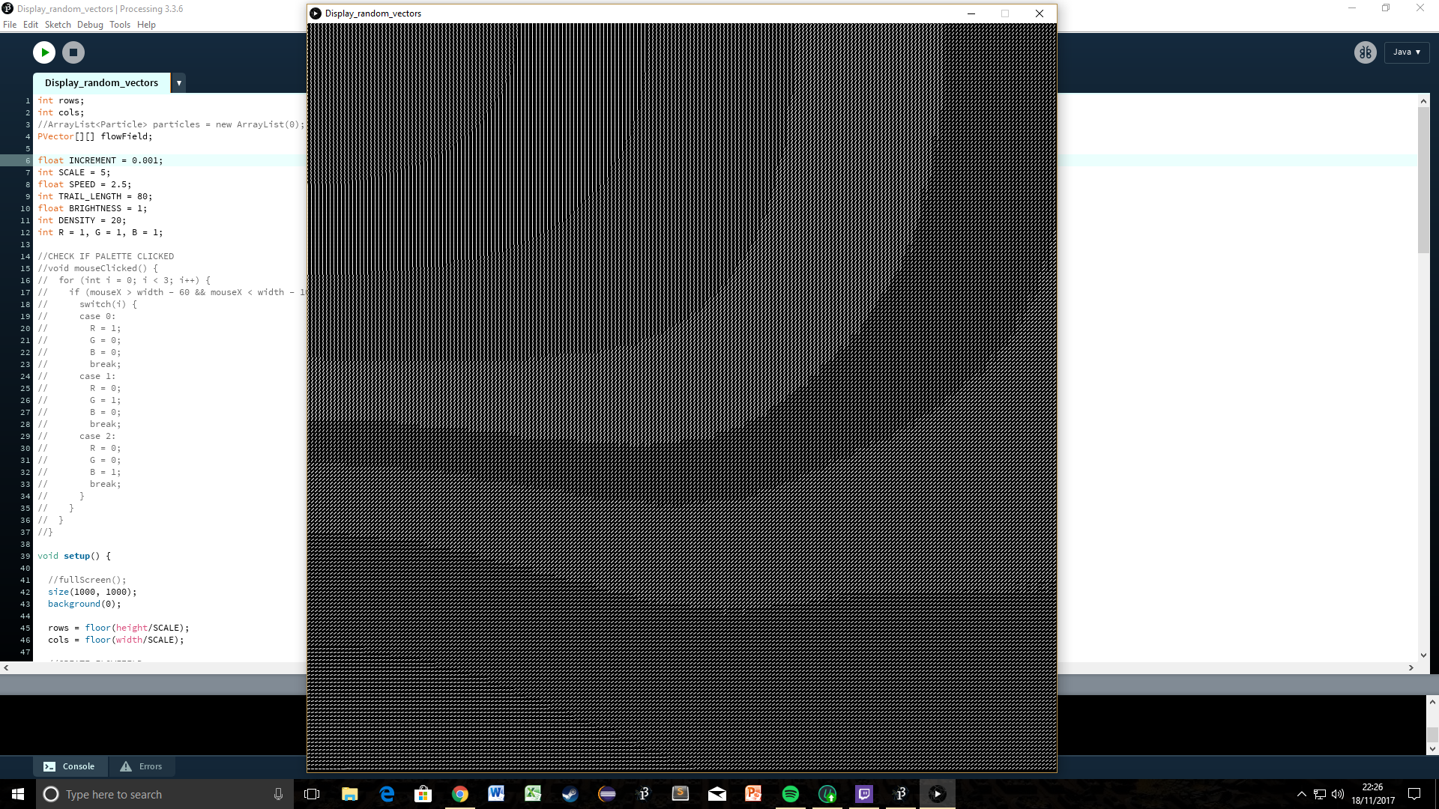

**Fig.33 - Flow field: Example g**

As in the last example the zoom level of the flow field has been altered by changing the value of INCREMENT. In contrast to the flow field pictured in figure 28 which had been zoomed out by a factor of 5 in comparison the figure 27, figure 29 has instead been zoomed in by a factor of 5 to examine an area of 2-dimensional Perlin Noise space that has dimensions a fifth as great.

After examining these results I have decided a zoom level of x200 will provide the most aesthetically pleasing flow field: it will be zoomed out enough to appear intricate but not too zoomed out so as to become messy. A SCALE of 1 has already been decided so by rearranging the “zoom” equation I have calculated I need to use an INCREMENT of 0.005 to achieve the desired 200x zoom.

### SPEED

#### When SPEED = 1

Shown from 1:34-1:43. When the maximum speed of particles is low the tendrils that spread from the mouse are short and become brighter quickly.

#### When SPEED = 3

Shown from 1:43-1:52. As the max speed has now increased particles are able to cover a greater amount of ground during their fixed lifespan. This has the result of making the tendrils longer. In addition particles are now moving a greater distance between each frame is drawn but are not being drawn more often to compensate, meaning they are essentially drawn less often in the same area. This has the result of tendrils become brighter at a slower rate.

#### When SPEED = 5

Shown from 1:52-2:06. The change here is similar to the change from SPEED = 1 to SPEED = 3 but just more exaggerated: tendrils are now even longer and dimmer.

After examining these results I have decided to go with a SPEED of 2.5. I feel that at this speed I am able to get the right balance between tendril length and brightness.

### TRAIL_LENGTH

#### When TRAIL_LENGTH = 30

Shown from 2:06-2:12.

#### When TRAIL_LENGTH = 80

Shown from 2:12-2:20. Individual particles now exist in the simulation for a greater length of time. This results in them leaving longer, more sprawling tendrils.

#### When TRAIL_LENGTH = 150

Shown from 2:20-2:33. It is clear that as the value of TRAIL_LENGTH increases so does the length of the tendrils. Changing the length of the tendrils by modifying the value of TRAIL_LENGTH has one main advantage over changing it by modifying the value of SPEED: the tendrils are not dimmed.

After examining these results I have decided to go with a TRAIL_LENGTH of 80. I fell that this is the optimum value in terms of aesthetic appeal when combined with a SPEED value of 2.5.

### BRIGHTNESS

#### When BRIGHTNESS = 1

Shown from 2:33-2:40. This is the lowest possible BRIGHTNESS, tendrils become brighter at the slowest possible rate.

#### When BRIGHTNESS = 5

Shown from 2:40-2:48. Increasing the BRIGHTNESS by a multiple of 5 has the effect of making tendrils brighten in a fifth of the time.

#### When BRIGHTNESS = 255

Shown from 2:48-2:55. Tendrils are now immediately at maximum brightness.

After examining these results I have decided to go with the minimum BRIGHTNESS of 1. Keeping the brightness as low as possible gives me the most scope to play with the effect of modifying other variables.

### DENSITY

#### When DENSITY = 1

Shown from 2:55-3:09. With a DENSITY of 1 it takes some time for the tendrils to become visible and when they do they increase in brightness very slowly.

#### When DENSITY = 20

Shown form 3:09-3:17. Tendrils become visible almost immediately and increase in brightness at an average speed.

#### When DENSITY = 100

Shown from 3:17-3:27. Tendrils become bright very quickly. When DENSITY is set to such a high number it results in there being a very large number of particles existing in the simulation at once. Having the handle all of these particles puts stress on the computer’s CPU and as a result frames begin to be dropped.

After examining these results I have decided to go with a density of 20: tendrils become brighter at the optimum rate.

## 

## Final draft screenshots:

In my final draft of the program I have used the constant values decided upon above. Here are some screenshots taken from that final program:

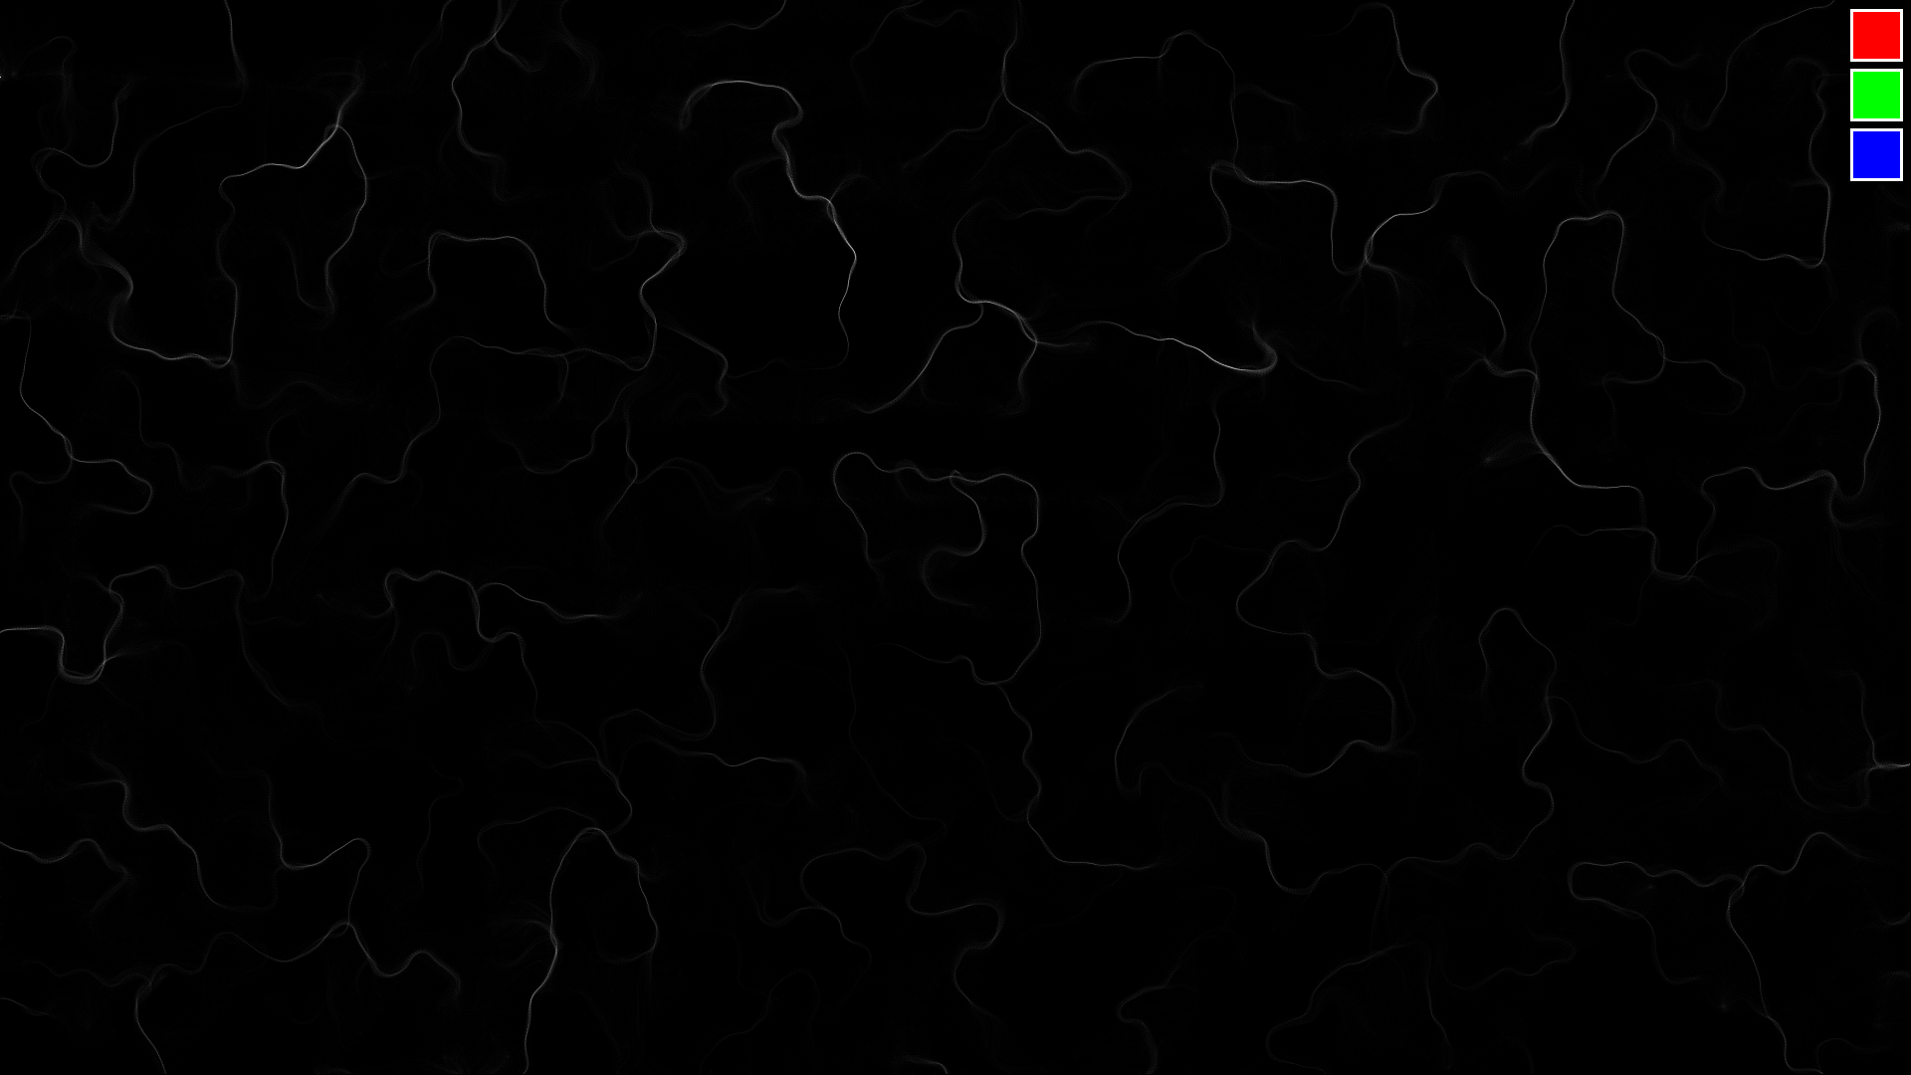

**Fig.34 - An even spread of particles**

In figure 33 I dragged the mouse around the screen distributing white particles evenly across the canvas.

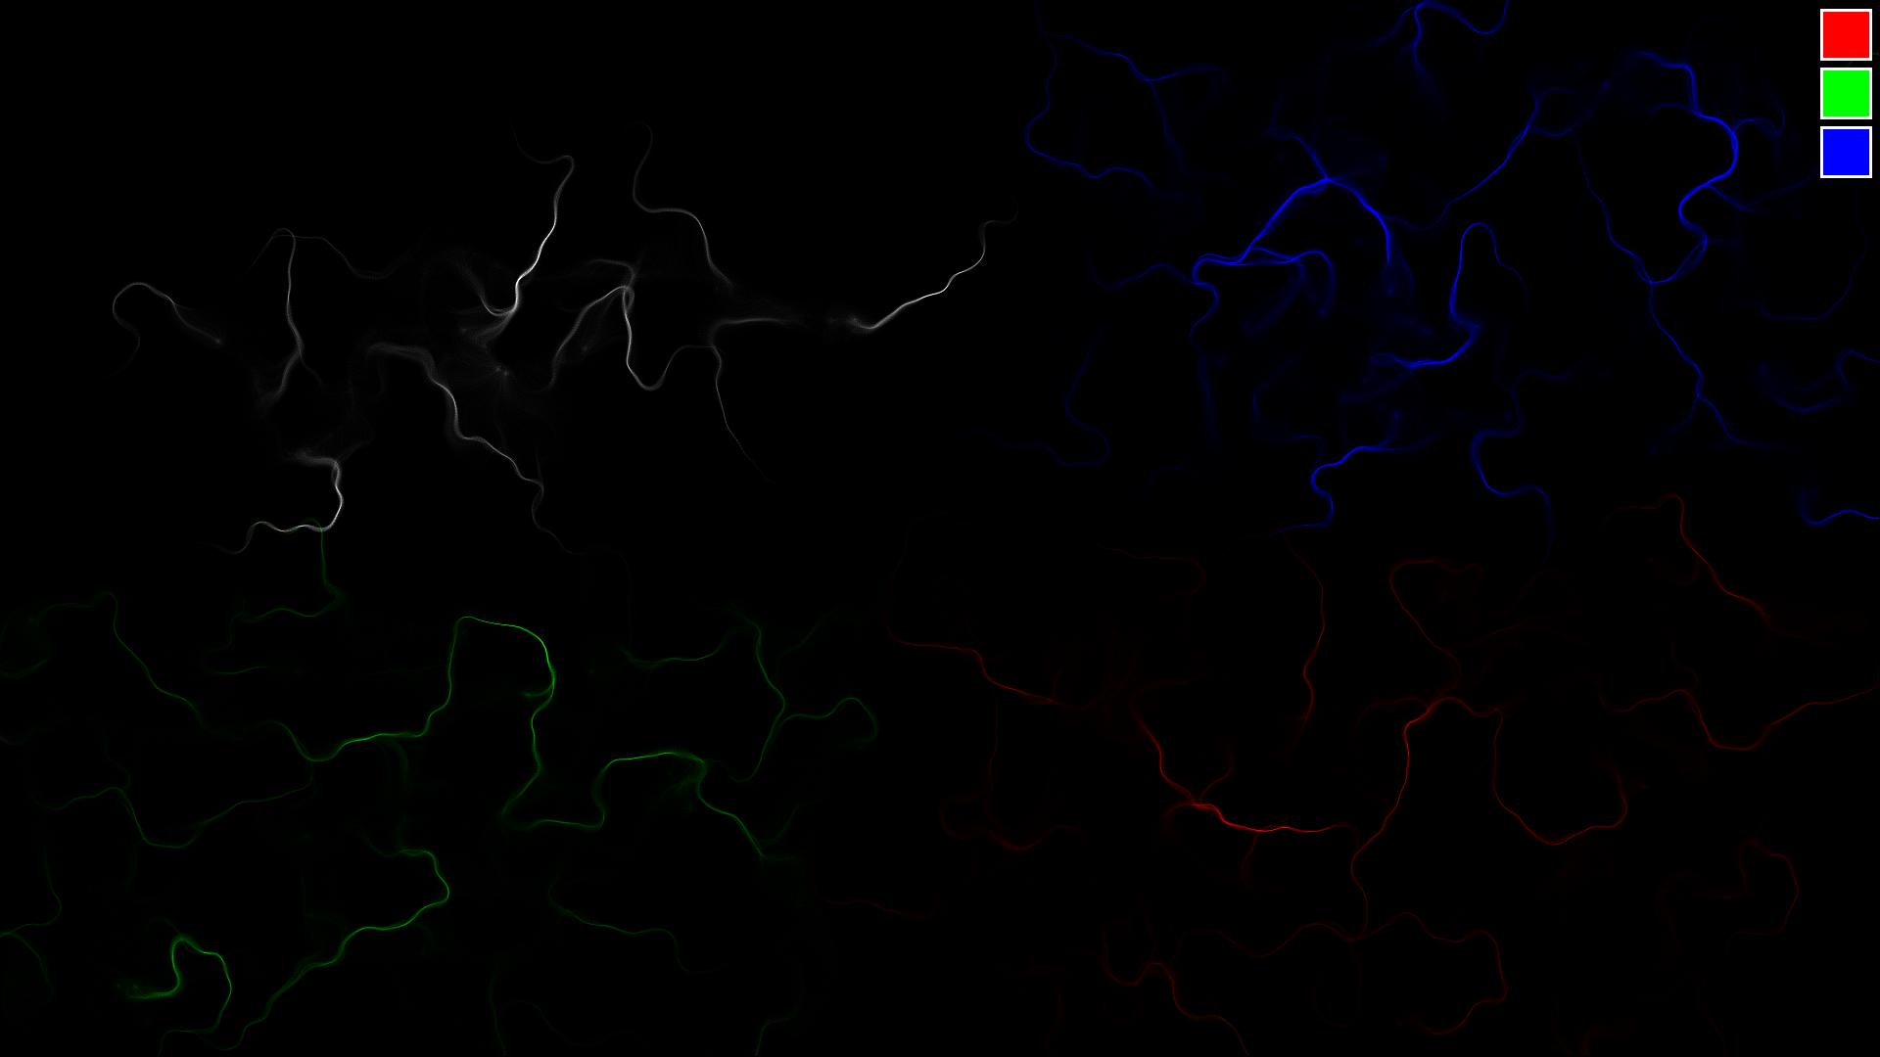

**Fig.35 - White, blue, green and red tendrils**

In figure 34 I spread some of each colour of particle in each quarter of the screen.

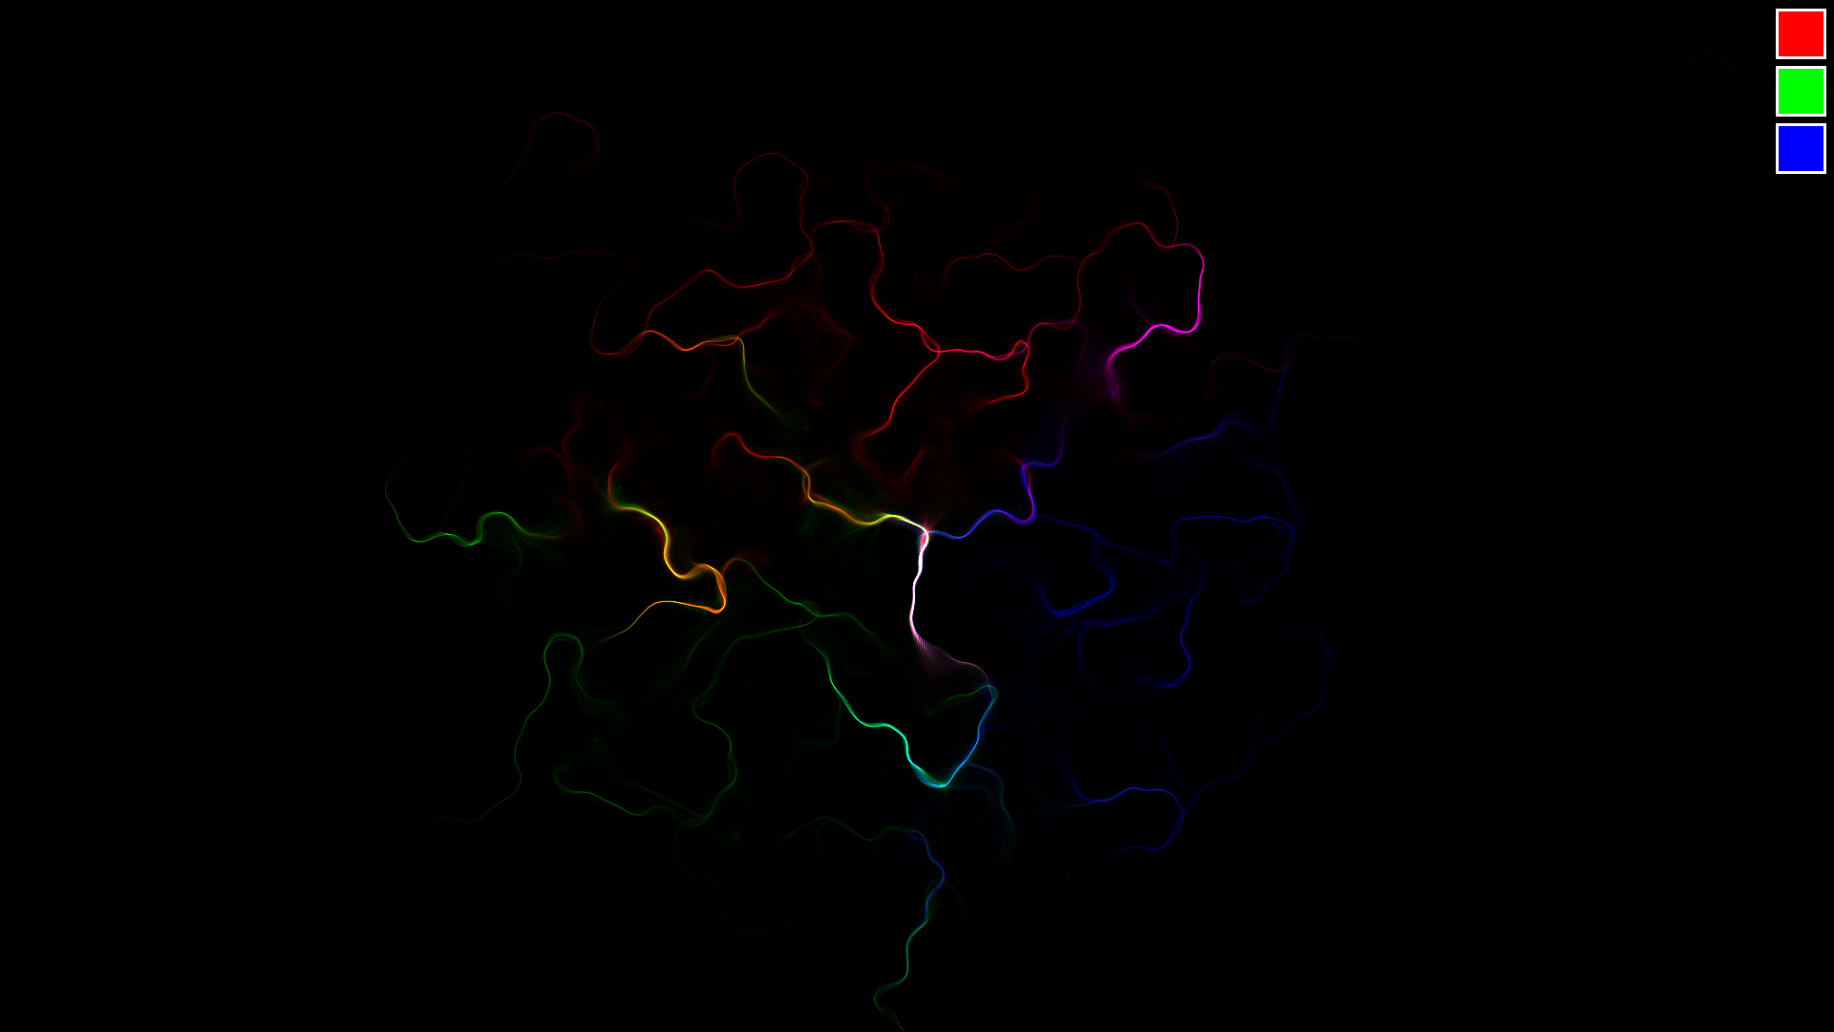

**Fig.36 - Red, blue and green tendrils mixing**

In figure 35 I produced a sort of Venn diagram with the 3 different colours of particle. Where red and green overlap it makes yellow, where green and blue overlap it makes cyan and where blue and red overlap it makes magenta. This is known as additive colour mixing.

# 

# Evaluation

I have evaluated my project based on the success I had completing each of the objectives I set out in the analysis.

## Construct a grid of unit vectors. Each vector’s direction will be related to its neighbours’ by passing the coordinates of its grid square into the 2-dimensional Perlin Noise function. Each vector represents a force that will be applied to any particle located in its respective grid square.

This objective was completed fully. Converting Perlin Noise values to angled unit vectors in an unbiased way was the biggest challenge I came across when completing this objective. This was due to the normal distribution of the Perlin Noise function, as I discussed in the technical solution section.

## Have a “Particle” object that is able to react to forces applied to itself by adjusting its vector fields for position, velocity and acceleration.

Using an object to represent the particles was a decision that worked out really well in the end. There were several benefits to using objects:

* Being able to store particles in an arraylist that’s type is the “Particle” object allowed to easily add to or remove particles from the simulation.
* Encapsulation meant the particle’s methods could be called multiple times throughout the program without having to reconsider the inner workings of the method each time - a simple understanding of the function’s parameters and purpose was all that was required.
* It made the program very well structured and much easier to understand - it is obvious to an outside reader what particle.move() will do.
* Giving the particle object vector fields for position, velocity and acceleration made implementing a basic physics engine into a very simple process with the use of SUVAT equations.

## Write a function that calculates which grid square each particle is located in so that the relevant force can be applied to the particle at the correct angle.

Locating the grid square turned out to not be a massively complex task. It was as simple of dividing the particles x and y coordinates by SCALE to ascertain the column and row of the square of the flow field grid the particle was located within.

## Add a mouse listener function that, when a mouse button is held, spawns particles onto the canvas in the region of the cursor.

Mouse listener functions are easy to use in processing - the hardest part was choosing the correct function for the job out of the six that were available. I initially used the mousePressed() function but quickly realised that it was possible to accidentally press the mouse while moving the cursor over the palette if you were moving it in a unspecific sweeping motion. The mouseClicked() function removes this issue by only calling its body after the mouse has been pressed and released.

## Remove particles from the simulation that pass outside the edges of the canvas to improve the efficiency of the programme.

This step was far more important for ensuring the effective running of the program than I predicted at the beginning of the project. While in theory the main issue with having particles off the screen was the undue strain it would place on the computer’s processing power there was instead a much larger issue it would cause.

When I ran the code without a function to remove particles that travel off the screen I was confronted by a NullPointerException error as soon as a particle moved beyond the limits of the window. By considering the code that calculates the column and row of the flow field grid that each particle is in it becomes obvious why this is the case. If a particle is outside of the window the row and/or column that it is in will either be larger than the largest index of the flowField array or it will be negative. In both cases the element of the flowField array that is being targeted will not exist, resulting in a NullPointerException.

The outOfBounds() method ensured this error cannot occur by removing any particle that was located in a position that would result in a non existent element of the flowField array being targeted.

## Give all particles a “lifespan” so when that set time elapses the particle is erased from the simulation.

This was essential for the aesthetic appeal of the program. By giving particles a randomised lifespan I achieved the visual effect of the canvas brightening much faster in the area of the screen immediate to the cursor. If it wasn't for this particles would travel the entire distance to a border before being removed by the outOfBounds() function.

An additional benefit to this was an improvement to the efficiency of the program. As a result of particles being removed at a set rate an unofficial cap was set on the number of particles it is possible to have existing on the screen at once. This maximum number of particles can be calculated using the following formula:



## Add a menu in the corner of the canvas that allows you to select the colour any new particles will be drawn as.

This was the greatest success of the program. It added another layer of visual complexity to the simulation; on top of playing with the swirling patterns you could now also mix different colours together to form swirls with new colours eg. where a red swirl and blue swirl cross it will become purple.

If I was to come back to this project this is where the development would take place. I might add more colours to the palette or add an eraser to the palette so you can clear individual areas of the screen.

## Change the way particles are drawn so the RGB value of the pixel where a particle is located is incremented by only a small amount, as opposed to changing the pixel to a block colour, to give the visual effect of the screen slowly becoming brighter in areas where more particles pass.

The completion of this objective was essential for achieving the look and feel I set out for at the beginning of the project. Without it there would be no “gradual brightening” of the canvas; instead the particles’ trails would be solid - there would be no effect when trails overlap and the screen would rapidly become saturated with indistinguishable trails.

In reflection Processing was the perfect language for this task. In no other language I am aware of is it so easy to manipulate the colours of individual pixels on screen. The built in pixels array made this objective much easier to complete.

## Independent review:

Here is a review given by one of my peers:

“The drawings you can make using this program are very visually interesting. It is not obvious at first how the code is achieving such a fluid looking animation, which adds interest. However the program gets boring after playing with it for 5-10 minutes as the drawings you can create look similar every time. Adding a menu from which you can change the visual style of the drawings would increase the amount of time you can play with the program for.”

## Improvements:

If I was to ever come back to this project in future some improvements I would make include:

* Add more colours to the colour selection palette.
* Add a settings menu that allows you to modify the values of the constants defined at the beginning of the program while you are using it.
* Add a menu for selecting the colour of the background.
* Add a button for wiping the canvas clean.
* Add a button that allows you to save the screen as an image file.

# Appendix

## Code

1. //DECLARE GLOBAL VARIABLES
2. int rows;
3. int cols;
4. ArrayList<Particle> particles;
5. PVector[][] flowField;
6. //INITIALISE CONSTANTS
7. float INCREMENT = 0.01;
8. int SCALE = 1;
9. float SPEED = 2.5;
10. int TRAIL_LENGTH = 80;
11. float BRIGHTNESS = 1;
12. int DENSITY = 20;
13. int R = 1, G = 1, B = 1;
14. //CHECK IF PALETTE CLICKED
15. void **mouseClicked**( ) {
16. for(int i = 0; i < 3; i++){
17. if(mouseX > width - 60 && mouseX < width - 10 &&

mouseY > 60 * i + 10 && mouseY < 60 * i + 60){ //CALCULATE WHICH TILE HAS BEEN CLICKED ON

1. switch(i){
2. case 0: //RED
3. R = 1;
4. G = 0;
5. B = 0;
6. break;
7. case 1: //BLUE
8. R = 0;
9. G = 1;
10. B = 0;
11. break;
12. case 2: //GREEN
13. R = 0;
14. G = 0;
15. B = 1;
16. break;
17. }
18. }
19. }
20. }
21. void **setup**() { //SETUP RUNS ONCE
22. fullScreen(); //SET WINDOW TO SAME RESOLUTION AS MONITOR
23. background(0); //BLACK BACKGROUND
25. //INITIALISE GLOBAL VARIABLES
26. rows = floor(height/SCALE);
27. cols = floor(width/SCALE);
28. particles = new ArrayList(); //INITIALISE AS EMPTY ARRAYLIST
29. //GENERATE FLOW FIELD
30. flowField = new PVector[cols][rows];
31. for (int y = 0; y < rows; y++) {
32. for (int x = 0; x < cols; x++) {
33. float n = noise(x * INCREMENT, y * INCREMENT); //GET PERLIN NOISE VALUE
34. float a = n * 4 * TWO_PI; //CONVERT NOISE VALUE TO AN ANGLE
35. PVector v = PVector.fromAngle(a); //CREATE UNIT VECTOR FROM ANGLE
36. flowField[x][y] = v;
37. }
38. }
39. }
40. void **draw**() { //DRAW FUNCTION RUNS ONCE EVERY FRAME
41. //ADD PARTICLES
42. if (mousePressed) {
43. for (int i = 0; i < DENSITY; i++) {
44. particles.add(new Particle(mouseX, mouseY));
45. }
46. }
47. //PARTICLE HANDLING
48. for (int i = 0; i < particles.size(); i++) {
49. Particle p = particles.get(i);
50. p.move();
51. //REMOVE PARTICLE IF OFF SCREEN OR EXPIRED
52. if (p.outOfBounds() || p.expired()) {
53. particles.remove(p);
54. continue;
55. }
56. //APPLY FORCE TO PARTICLE
57. int x = floor(p.pos.x / SCALE);
58. int y = floor(p.pos.y / SCALE);
59. PVector force = flowField[x][y];
60. p.applyForce(force);
61. }
62. //DRAW PARTICLES
63. loadPixels();
64. noFill();
65. for (Particle p : particles) {
66. p.show();
67. }
68. updatePixels();
70. //DRAW COLOUR PALETTE
71. stroke(255);
72. strokeWeight(3);
73. fill(255, 0, 0);
74. rect(width - 60, 10, 50, 50); //RED TILE
75. fill(0, 255, 0);
76. rect(width - 60, 70, 50, 50); //BLUE TILE
77. fill(0, 0, 255);
78. rect(width - 60, 130, 50, 50); //GREEN TILE
79. }
80. //PARTICLE CLASS
81. class Particle {
82. PVector pos;
83. PVector vel;
84. PVector acc;
85. int lifespan = floor(random(20, TRAIL_LENGTH)); //RANDOMISED LIFESPAN
86. int aliveFor = 0;
87. float limit = random(SPEED, SPEED + 1); //RANDOMISED SPEED
88. Particle(int x, int y) { //CONSTRUCTOR FUNCTION
89. pos = new PVector(x, y);
90. vel = PVector.random2D().mult(random(SPEED)); //RANDOMISED INITIAL VELOCITY
91. acc = new PVector(0, 0);
92. }
94. //ADJUST POSITION, VELOCITY AND ACCELERATION
95. void move() {
96. vel.add(acc);
97. vel.limit(limit);
98. pos.add(vel);
99. acc.mult(0);
100. }
102. //SET ACCELERATION EQUAL TO THE APPLIED FORCE
103. void applyForce(PVector force) {
104. acc.add(force);
105. }
107. //DRAW PARTICLE ONTO CANVAS
108. void show() {
109. int loc = floor(pos.x) + floor(pos.y) * width; //CONVERT 2D POSITION TO 1D ARRAY INDEX
110. int c = pixels[loc]; //GET COLOUR OF PIXEL
111. float r = red(c) + BRIGHTNESS * R;
112. float g = green(c) + BRIGHTNESS * G;
113. float b = blue(c) + BRIGHTNESS * B;
114. pixels[loc] = color(r, g, b); //UPDATE PIXEL TO NEW COLOUR
115. }
117. //RETURN WHETHER PARTICLE IS OFF SCREEN
118. boolean outOfBounds() {
119. return (pos.x > width - 1 || pos.x < 0 || pos.y > height - 1 || pos.y < 0);
120. }
122. //RETURN WHETHER LIFESPAN HAS BEEN EXCEEDED
123. boolean expired() {
124. if(aliveFor > lifespan) {
125. return true;
126. }
127. aliveFor++;
128. return false;
129. }
130. }